# TripleA Rule Book

# The World’s Foremost Open-Source Grand Strategy Game

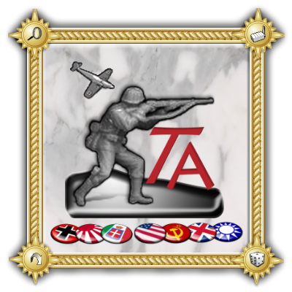

*Rule Book and Manual version 1.0*

*Created for TripleA version 1.5.0.0*

*(January 2012)*

Table of Contents

**Overview3**

**Game Setup4**

**The Game Screen5**

**The Map6**

*Capitals*7

**The Units7**

*Units Used in “Big World : 1942”*8

**Sequence of Play12**

*Technology Development*12

*Purchase*14

*Combat Movement*14

*Battle*16

*Non-Combat Movement*18

*Placement*19

*End-Turn*20

**Winning the Game20**

**The Undo Feature21**

**Low Luck vs. Dice21**

**The Battle Calculator22**

**Menus & Tabs23**

**Credits24**

**Links24**

**Appendices & Additional Content25**

*Example of Play: 1st Turn Walkthrough of Russians in “Big World : 1942”*25

*Pulicat’s Tactical Handbook*36

# Header Overview

TripleA is a turn-based strategy game and board game engine. Though TripleA comes with many games inside, it is just an engine for playing games, and is not a game itself. TripleA started out as a World War II simulation, but has since expanded to include different conflicts, as well as variations and mods of popular games and maps (a ‘map’ is like a board, while a ‘game’ is a specific setup on a map/board).

This manual describes how to use and play TripleA, using the game “Big World : 1942”, a basic variant. The two most popular WWII maps for beginners are “Pact of Steel” and “Big World”, and Big World has a lot more territories and a one more unit type than Pact of Steel, while the rules are almost exactly the same. Other TripleA games and variants can still use this manual as a good starting point, because the game engine and most of the concepts are the same no matter what map or conflict you are playing.

This manual does not attempt to describe 100% of the game functions. There are just too many things that the game can do to make that practical. Some of the game interfaces and operations are intended for developers. Many of the game operations simply happen automatically, and illegal player actions are prevented. A certain amount of knowledge and initiative is expected of the player, especially to read any game notes for any maps. However, all of the critical and important game operations and knowledge are described in this manual.

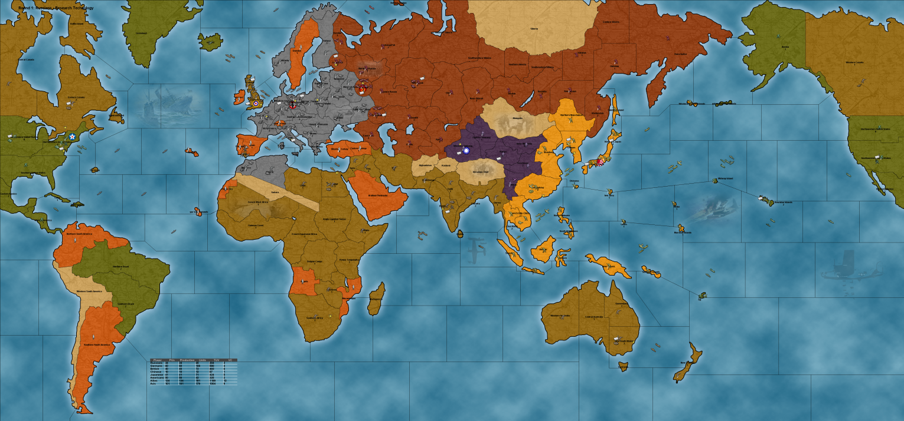

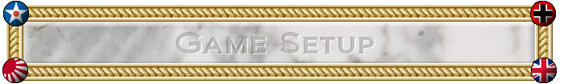

The first thing that happens when TripleA is started is that the game setup window appears. There are a number of choices that the player must make at this time.

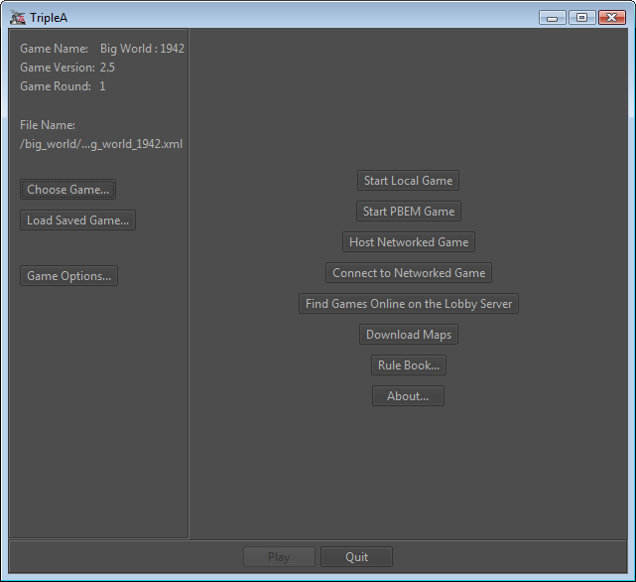

* The game variant must be selected, OR a saved-game must be loaded.
* Approximately 10 or more variants are automatically included with the game, and more can be downloaded.
* The game options should be set, but the default ones could be used.
* A local, pbem, or network game can be started, OR you can join the online lobby instead. *(Even if loading a savegame, you must still select ‘start local game’ or ‘start pbem game’ or ‘host networked game’)*
* Each player can be set to be a human or an AI.

A few other options are also available at this time, but they can be ignored for now.

# Header The Game Screen

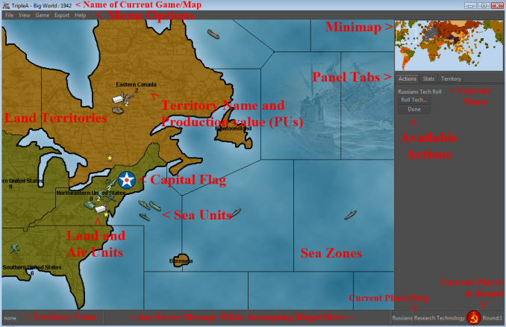Below is a screenshot taken while in-game, playing the “Big World : 1942” map.

Usually, the main screen cannot display the whole world at once, and instead only shows part of the map. The part that is displayed can be rapidly moved or changed in three ways:

* By moving the cursor to just inside the edge or corner of the main map window, at which point the map will scroll in that direction. Scrolling the mouse wheel will also scroll the map up and down.
* By ‘right-clicking’ on the main screen and dragging your mouse to move around the map.
* By clicking or clicking and dragging on the minimap in the upper right-hand corner.

In addition, you can change the Zoom Level of the map by either going to the “View” menu and selecting “Zoom”, or by holding down the “ALT” key while scrolling your mouse wheel.

# Header The Map

Each TripleA map is divided into a number of areas. Land areas are called territories. Sea areas are called sea zones. Short or narrow rivers and small islands generally play only a cosmetic role (if an area has no name when you scroll your mouse over it, then it is just cosmetic and not an actual territory or sea zone). Air units fly over top of all this, but need to land at the end of every turn.

Each map area is adjacent to a certain number of other areas. Units move about the map, from one area to an adjacent area; as a general rule, teleportation does not exist.

Land units are restricted to land territories unless they are being carried by transports. Sea units are restricted to sea zones. This means that land and sea units generally cannot attack each other.

Sea units can generally move to any adjacent sea zones, but there is one exception to this rule: Canals. Canals are connected sea zones that require ownership of attached land territories in order to pass through. For example, at the Suez Canal, sea units can move north and south via the canal, but only if the land territories on both sides of the canal are controlled by friendly or allied nations at the beginning of your turn.

Each territory has a production value (Production Units, or PUs for short), which could be as low as zero. It is possible for sea zones to be assigned production values as well, in which case they would be called ‘convoy centers’. The production value of a land territory determines how many units can be produced there per turn, but, primarily it determines how much income that territory provides per turn to the player controlling it.

Each land territory is always controlled by some player, except for some territories that are initially neutral or are impassible to all players. A territory can change hands if an enemy land unit conquers and occupies it. Some land units, such as Anti-Aircraft guns (AA Guns), cannot attack and conquer a territory. The color of the territory on the map indicates who controls it.

The player who controls a particular territory receives the income from it at the end of that player’s turn. Control of a territory may change many times in a game round, and the territory will still produce its full income with each change of control.

Certain territories contain “Factory” units, which allow the controlling player to produce units in that territory. A territory with a factory may produce a number of units up to the production value of the territory, if the player owned that territory at the beginning of their turn. When a player conquers a territory containing a Factory or AA Gun, those units will be captured with the territory, and the conquering player may use them on their next turn.

The territories that a player starts the game with are considered to be “originally” owned by that player, unless otherwise specified. If an ally ever recaptures such a territory, control of the territory (and its resources and capture-able units) will revert to the original owner. In this case, the income for the territory is not collected by the capturing player, and instead it will be collected by their ally, the original owner, at the end of their turn, provided that they still own it at that time. Of course, enemy players are not bound by such considerations and control whatever they capture.

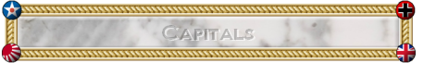

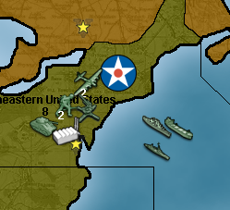

Each of the nations in TripleA has a capital territory. These territories are indicated on the map by a large roundel or flag associated with that nation. If an enemy player captures one of these territories, there are drastic consequences.

* All of the production units (PUs) in the victim’s bank are immediately transferred to the treasury of the capturing player.
* The victim does not collect any income while the capital is in enemy hands.
* The victim cannot produce any units while the capital is in enemy hands. Of course, he has no resources to produce those units in any case.

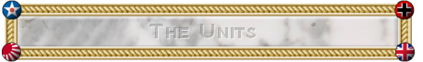

As most games on TripleA are “grand strategy” games, a “unit” does not represent a single infantry or tank, but instead represents an entire army that is based around infantry or tanks. Therefore an “infantry” unit would include within it its own logistics train, supplies, anti-air/tank weapons, etc. Unless specified, all units can hit all other units.

Each TripleA unit has certain properties, which are expressed as a set of numbers. These properties are Attack (Att), Defense (Def), Movement (Move), Cost (PUs), Hit-Points, Size, and maybe some special properties or abilities.

**Attack** is the firepower when a unit is attacking. The unit gets one hit by rolling that number or less on a 6-sided die.

**Defense** is the firepower when a unit is defending. The unit gets one hit by rolling that number or less on a 6-sided die.

**Movement** is the number of map territories or sea zones that the unit can move each turn (except when being carried by a transport). A unit with a Movement of 1 can move to one adjacent area, and so forth.

**Cost** is how many PUs must be spent to produce one of that unit.

**Size** indicates how much transport or carrier capacity is required to move a land or air unit by sea.

**Hit-Points**  indicates how many hits this unit must suffer before it dies. Almost all units in TripleA have only 1 hitpoint, meaning that they die after the first hit. Some special units, like Battleships, may have 2 hitpoints, which allows them to absorb enemy fire, and possibly repair if they survive the battle.

Important special properties and abilities are things such as being able to Blitz, or being able to increase the attack power of another unit when they are in the same territory (called giving and receiving “support”), or being able to shoot at aircraft as they fly over, or being able to produce units.

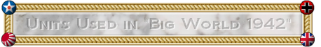

The following units and stats are particular to the game “Big World : 1942”, and therefore if you try playing a different map, the units might differ slightly. For example, “Pact of Steel” has no “Cruisers” and the “Destroyers” cost more and have higher attack and defense. In some maps not based on World War II, the units may differ radically. For example, “Lord of the Rings: Middle Earth” has completely different units, different art, and different stats.

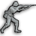**Infantry** **attack**, **defense**, **movement**, **cost**, **hitpoint**, **size**

Special Abilities:

* + Infantry may receive support. This means when they are paired with Artillery units on a 1-to-1 basis, the infantry units will receive +1 attack power.

Notes: Infantry is generally slow and cheap with a high defense. Accordingly, its primary missions are to defend territories and to absorb casualties. Despite their lower attack and defense, they still have just as many hitpoints as more expensive units, so it is very good to keep more infantry than any other unit.

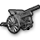

**Artillery**  **attack,** **defense,** **movement, cost,** **hitpoint,** **size**

Special Abilities:

* + Artillery may give support. So as an example, if you had 3 infantry and 2 artillery, then 2 of the infantry would receive support and have their attacks increased to 2, while the 3rd infantry would stay at 1 attack. The support is not cumulative, so 1 infantry with 2 artillery would only receive 1 support.

Notes: Artillery is used to increase the attacking effectiveness of your infantry stacks. It is generally good to have a few artillery with every large stack of infantry, as it is a very cost effective way of increasing the firepower of your army.

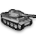**Armour** **attack,** **defense,** **movement, cost,** **hitpoint,** **size**

Special Abilities:

* + Armour has the ability to “Blitz” through empty enemy territories. This means that while normally units must stop in the first enemy territory they enter, armour has the ability to keep moving if the enemy territory is empty of enemy units. The blitzing unit conquers this territory, and then can continue moving, going deeper into enemy territory or even returning to friendly territory.

Notes: Armour is used for rapidly attacking an enemy, and being able to respond quickly to opportunities that are too far away for infantry to reach in time.

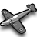

**Fighter** **attack, defense, movement, cost,** **hitpoint,** **size for**

**carriers**

Special Abilities:

* + All air units in TripleA share 2 abilities:
    - Air units cannot end the turn in a land territory which was fought over or conquered this turn. In other words, they must move out of the territory where they fought, and land in a territory that was friendly at the beginning of the turn, or on a friendly carrier which has space left.
    - Air units cannot capture territories.
  + Fighters can land on Aircraft Carriers.

Notes: Fighters are used for their flexibility in having 4 movement, and because they can attack both land and naval targets. While all land units lose their movement when they participate in a battle, air units can continue moving after a battle is finished, giving them the ability to get out of harm’s way in case the enemy does a counter-attack.

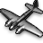**Bomber attack,** **defense, movement, cost,** **hitpoint**

Special Abilities:

* + In addition to normal air abilities, Bombers have the ability to do a “Strategic Bombing Raid” on any enemy factory. Generally speaking, each bomber that survives any AA shots will get to roll a 6 sided die, and do that much damage to the enemy’s PU supply or to the individual factory (however the total damage per bomber cannot exceed the PU value of the territory).

Notes: The additional movement and attack, as well as the ability to raid enemy factories, make bombers a deadly but expensive unit.

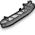**Transport attack,** **defense,** **movement, cost,** **hitpoint, capacity**

Special Abilities:

* + Transports have the ability to carry land units. They can carry 1 infantry unit plus 1 more land unit of any kind (e.g. 2 infantry units, or 1 infantry and 1 artillery / armour / AA Gun.
  + In “Big World : 1942” and many other maps, Transports may be taken as casualties like any other unit. However, in some maps, Transports may not be taken as casualties until all combat ships are dead.

Notes: Transports are used for moving land units over the sea zones.

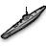**Submarines** **attack,** **defense,** **movement, cost,** **hitpoint**

Special Abilities:

* + Submarines may “submerge” at the end of a round of battle, which effectively retreats them out of a battle but keeps them in the same sea zone.
  + Submarines may move through enemy sea units, if the enemy units do not include a “Destroyer” unit.
  + Submarines always attack at the beginning of each combat round. If the enemy has no “Destroyers” present, any casualties the submarines inflict do not get to shoot back.
  + Submarines may not attack air units, ever. Air units may attack Submarines though.

Notes: Submarines are stealth units, and one of the cheapest units at sea, and are very useful in attacking enemy sea units and for use as cannon fodder during sea battles.

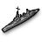**Destroyer** **attack,** **defense,** **movement, cost,** **hitpoint**

Special Abilities:

* + Destroyers have the ability to cancel all of the abilities of enemy submarines.

Notes: Destroyers are also one of the cheapest units at sea, and are better at defending since they can defend against air units. It is good to have destroyers whenever the enemy has submarines.

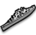**Cruiser** **attack,** **defense,** **movement, cost,** **hitpoint**

Special Abilities:

* + Cruisers have no special abilities on “Big World : 1942”, however on other maps they often have the ability to bombard an enemy ground position.

Notes: A middle-cost sea unit.

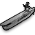**Carrier** **attack,** **defense,** **movement, cost,** **hitpoint,** **carrier**

**capacity**

Special Abilities:

* + Carriers have the ability to carry 2 friendly (owned or allied) fighters over the ocean. These fighters will help defend your fleet, and can be used to attack enemy positions out of range.

Notes: Carriers are useful only in their ability to hold fighters. Since fighters are more cost effective than most naval units, they add greatly to your fleet’s abilities. (Technically, the carrier does not “carry” the fighters, unless it is an allied fighter as cargo, it merely provided a landing place for the fighters at the end of the player’s turn. When the player’s turn starts, all owned fighters are considered to have launched from the carrier and are now in the air, so fighters and carriers move independently of each other.)

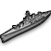

**Battleship attack, defense,** **movement, cost,** **hitpoints**

Special Abilities:

* + Battleships have 2 hitpoints. If damaged in battle but still alive after the battle ends, all battleships will repair to full health after the battle is over.
  + Battleships can bombard enemy land territories, if there is a transport unloading ground troops from the same sea zone into an amphibious assault on that land territory. So, if there is an amphibious assault, the battleship may roll a single die at 4 before the battle begins in order to try to cause an enemy casualty.

Notes: Battleships are used both for their ability to absorb and repair hits, and to bombard enemy territories.

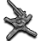**AA Gun attack, defense,** **movement, cost,** **size**

Special Abilities:

* + AA Guns have a special ability that activates before a battle or strategic bombing raid begins, and when air flies over a territory containing an AA Gun. They will roll a single die at 1, for each attacking aircraft in the battle. Any air that is hit immediately dies, with no chance to fire back.
  + AA Guns do not participate in battle, and if the attacker wins, the AA Gun is captured by the attacker.
  + AA Guns may not move during combat movement, they may only move during the non-combat move phase. They may never be on the attacking side of a battle, only on the defending side.

Notes: Anti-Aircraft Guns are used to defend against Strategic Bombing Raids, and are also used to make an attacker think twice before they use overwhelming air power to attack your territories.

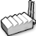**Factory attack, defense, movement, cost**

Special Abilities:

* + Factories allow their owner to produce units in the territory the factory is located in (or in the Sea Zone adjacent to the factory). The Factory will allow production of any number of units, up to the Production value of the territory it is in. Having multiple factories in a territory does not increase this limit.
  + Factories do not participate in combat, and if an attacker conquers the territory they will automatically capture any factories in the territory. Factories can be targeted in Strategic Bombing Raids.

Notes: Factories are vital centers of production, allowing their owner to produce units in that location.

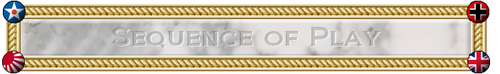

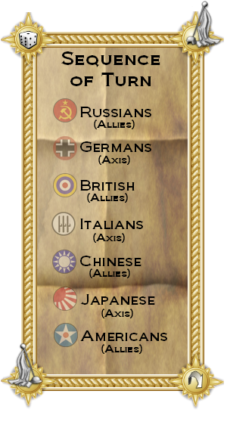

TripleA is played in a series of rounds, with each round composed of a series of player turns, and each player turn composed of a series of phases (also called steps).

**The sequence of turns for Big World : 1942 is:**

1. Russians (Allies)
2. Germans (Axis)
3. British (Allies)
4. Chinese (Allies)
5. Japanese (Axis)
6. Americans (Allies)

Once the Americans finish their entire turn, the current “round” is over. TripleA then checks for victory conditions to determine if one side has won the game or not. If no side has won, then the next round starts, beginning with the Russians again.

**The standard sequence of phases is:**

1. Technology Development
2. Purchase
3. Combat Move
4. Battle (resolving combat)
5. Non-Combat Move
6. Placement
7. End of Turn (accounting)

A player may choose to do nothing in certain phases, and, depending on the circumstances, some phases may not occur. Almost all phases require the user to press a “Done” button on the right side of the screen in order to progress to the next phase.

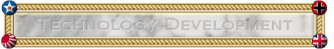

In the **Technology Development Phase**, a player may spend production units (PUs) to attempt to acquire new technologies. This involves purchasing die rolls, and generally for every 5 PUs spent, 1 additional die is purchased (a 1/6 chance each). The player then chooses which technology they wish to roll for, and then all of the dice are rolled. If one or multiple 6’s are rolled, the technology is discovered and all dice are discarded. If no 6’s are rolled, then nothing happens and the dice are discarded as well (in some maps, they player keeps the dice and may roll during their next turn).

Technology generally improves a player’s units, or allows production of advanced units. Generally any technologies discovered are then activated at the end of the player’s turn (though in some maps, the technologies are activated right after they are discovered).

PUs not spent in this phase are saved for later use, like in the Purchase Units phase.

# Available Technologies

Once activated, Technology in “Big World : 1942” provides the following benefits. In other maps, different technology may be available, or the same technology as below but with slightly different results (like ‘Jet Power’ increasing attack power instead of defense power). Technologies only affect the player who discovered the technology, and do not affect any other players.

* **Jet Power**: Each Fighter’s defense power is increased by 1.
* **Super Subs**: Each Submarine’s attack power is increased by 1.
* **Long Range Aircraft**: Adds 2 to all aircraft range.
* **Rockets**: Your AA Guns gain the ability to launch rockets:
  + At the end of your combat move phase, each of your AA Guns may attack enemy factories within 3 movement away from the AA Gun. Generally each enemy factory can be targeted by only one rocket, and rockets may only target one factory. The damage is a single 6 sided die, but limited to the production value of the target territory, and the victim immediately loses that number of PUs (or in some maps, the factory will be damaged instead).
* **Destroyer Bombard**: Each of your Destroyers may conduct shore bombardment.
* **Heavy Bomber**: Each of your bombers rolls 2 dice when attacking and raiding (if ‘LHTR’ rules is turned on, then only the better result is used. If not, then both dice count.)
* **Industrial Technology**: All of your units cost one PU less. (Industrial Tech is considered an ‘optional technology’ and both players must agree to allow this tech before the game starts, otherwise it should not be researched.)

For all of the technologies, except Destroyer Bombard and Industrial Technology, the units will visually change to have new icons.

Some technologies available on other maps, but NOT available on “Big World : 1942”, are:

* **Advanced Artillery**: Each artillery provided double the number of support (i.e.: supports up to 2 infantry instead of 1).
* **Paratroopers**: Bombers may now transport a single infantry into combat. Neither bomber or infantry can move before the infantry loads. The movement must be to a battle, and movement ends in the first enemy territory reached.
* **Increased Factory Production**: Factories in territories valued 3 or greater may produce 2 additional units. In addition, repairing is done at half price.
* **War Bonds**: At the end of your turn, roll 1 die and collect that much income.
* **Mechanized Infantry**: Each armour may transport a single infantry with it as it moves.
* **Improved Shipyards**: Naval units are cheaper to purchase.
* **Radar**: AA Guns now fire at +1 attack (2 instead of 1).

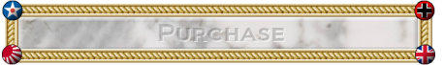

In the **Purchase Phase**, a player may spend PUs to purchase new units. These units may be placed on the map in the Unit Placement Phase at the end of the turn.

At the start of the Production Phase, a menu appears offering the current player the chance to produce new units. Any combination of available units may be purchased, subject only to the limitation that the total cost does not exceed the available PUs. Any PUs not spent in this phase are saved for later use and accumulate without limit.

The unit purchase menu choices are to add or remove one unit of a given type, or to buy as many as possible or zero of a given type. You may also enter a specific number with your keyboard. The unit purchase menu may be closed and restored multiple times during the Purchase Phase and changes can be made freely, all without penalty.

If a player attempts to purchase more units than can actually be placed on the map, the game provides a warning and lets the player change their purchase choice, but the player is not actually prevented from doing so if they insist.

In some newer maps, you may also repair damaged factories and units during this step. A factory that is damaged produces less units (1 unit fewer for each point of damage), and so they must be repaired by a certain amount in order to produce all the units you wish to purchase.

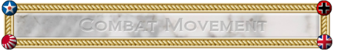

In the **Combat Movement Phase**, the current player may move any or all of his units to the full limit of their movement allowance, with certain exceptions.

* Certain units, such as AA Guns, may not move in this phase, as they can only move in the Non-Combat-Movement Phase.
* Air units may not move so far that their remaining movement allowance is insufficient for them to return to an eligible landing area – that is, air units generally may not commit suicide in this manner. The program does not always properly calculate ranges for fighters moving over large bodies of water; it assumes that nearby carriers will move to pick up the fighters. A player could abuse this to circumvent the “no suicide” rule. However, it is the player’s responsibility to ensure that each of his air units can possibly land at the end of this turn.
* Land and sea units (except submarines if no enemy destroyer is present) must stop moving as soon as they enter an area occupied by an enemy or neutral unit, or a neutral territory. Most land units having a movement allowance greater than one may move through an empty territory controlled by an opposing player without being required to stop, capturing that territory as they go. This is called “blitzing”. Neutral territories normally cannot be blitzed.

Only in this phase may units enter into any form of combat situation. If a player moves units into a territory or sea zone owned by the enemy, or containing enemy units, then the units must stop and participate in a battle during the next phase. Unlike games such as “Risk”, you may not make a combat movement, then conduct combat, then make more movement and conduct more combat. In TripleA, all movement to attack an enemy must be made at once, during this phase, and after this phase is over all combat will be completed at the same time. After this phase is finished, there will be no more movement to attack enemies allowed, until the player’s next turn.

At the end of this phase, combat must be resolved for each territory or sea zone in which the current player has at least one unit and an enemy player or neutral has at least one unit.

Units that do not use up their full movement allowance in this phase retain the remainder for the Non-Combat Movement Phase, except for land and sea units that engage in combat. Land and Sea units that engage in combat lose their remaining movement points.

Illegal moves are not permitted. If a move is attempted with a group of units that is illegal for some of those units, a warning is given, and only the legal parts of the move will execute. For some complex moves, further input is required, and the player will be asked to provide it.

As the movement phase progresses, a list of all moves made so far is displayed on the right side of the screen. Any one of these moves can be cancelled and undone at any point until the player manually ends the phase, except that moves that are prerequisites for other moves cannot be cancelled without cancelling the dependent moves first.

### Transports

Certain sea units (transports) may transport land units. A typical transport can carry one foot infantry and one more unit, although this may be different on other maps.

The procedure is that a land unit moves onto a transport in an adjacent sea zone and later moves onto a territory adjacent to the transport. The transport may move at any point in this process. The land unit may unload on the same turn or later, and may remain on the transport indefinitely. Land units may load onto one transport from different territories and at different times, but a transport may only unload to one territory per player turn, and if it unloads, it may not move any more in that player turn. Land units may not move before they load onto a transport.

Transportation may also occur with units of allied players, although the process is not as seamless as when the transported units belong to the same player as the transport. This is because when you move a unit onto a transport you own, you may unload that unit on the same turn. But when you move a unit onto an ally’s transports, that unit may not unload until the next turn.

**Carriers and Fighters**

At the beginning of the turn, all of the current player’s owned fighters launch from any carrier they were on. They are considered to be in the air, not on board a carrier.

This means that when you are moving the carrier, the air units do not move with it. Carriers cannot be used to give air units ‘extra’ movement.

All owned air units stay in the air until the end of the current player’s turn.

The only exception is that allied air units remain on-board a carrier, and do not launch. These air units are considered to be “cargo” and do not participate in attacks. If the carrier dies, the allied air “cargo” will die too.

### How to Select and Move Units

* To pick up a unit, **left-click** on that unit.

Then move your mouse to the territory where you want the unit to go, and left-click again to move it there.

Do NOT left click and drag your mouse at the same time. Instead you have to click, then move the mouse, then click again.

* To de-select the last unit selected, **right-click**. To deselect a specific unit, right-click on that unit’s stack.
* In addition to these basic methods, there are some more shortcuts
  + CTRL-Left click on a unit stack to select all units in the stack.
  + CTRL-Right click on a unit stack to de-select all units in the stack.
  + Shift-Left click on a unit to select all units in the territory.
  + CTRL-Right click somewhere not on a unit stack to de-select all units. Or hit ESC to deselect all.
  + Left click in the territory, but not on any unit, to bring up a menu allowing detailed selection of multiple units.

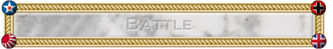

In the **Battle Phase**, each territory or sea zone where both the player has units, and any enemy has units, will create a “battle” that must be resolved. A list of these territories and sea zones will appear on the right side of the screen. The current player may resolve these in any order he wishes, but there are some exceptions, such as amphibious invasions and strategic bombing raids, which must be done first, but all battles must be resolved during this phase.

If a territory contains more than 2 different players (nations), then only the units owned by the current player are considered to be “attacking”. Any units which are enemies of the current player are considered to be “defending” (including all air units on carriers). In this way, many nations may defend, but only one nation may attack during each turn. Multinational attacks are not possible in most maps.

Each battle proceeds in a series of rounds, until at least one side is destroyed or retreats. The attacker may retreat at the end of any round. Both defending and attacking subs (stealth units) may retreat (submerge) at the end of any round if no enemy destroyers are present (in some maps, submarines may retreat before the battle starts as well).

Each combat round proceeds in a series of segments. Unless otherwise specified, all units of both attacker and defender get to fire once per battle round, even if the unit is selected to be a casualty. The segments of battle are as follows:

1. First, attacking subs (stealth units) fire, and the defender allocates the casualties. If the defender has no anti-stealth units (destroyers) present, the non-submarine casualties are removed immediately and do not participate further in this combat.
2. Next, defending subs fire using the equivalent procedure. If the attacker has no destroyers present, the casualties are removed immediately and do not participate further in this battle.
3. Next, any remaining attacking units fire, and the defender allocates the casualties.
4. Next, any remaining defending units fire using the equivalent procedure, and the attacker allocates casualties.
5. Allocated casualties are now removed from the game. If one side has no more units, then the other side wins (and if the attacker wins, they conquer the territory).
6. If the defender has any submarines, they may choose to submerge them now. The attacker may then choose to submerge their submarines.
7. The attacker then chooses whether to retreat, or press on. If the attacker retreats, then all non-air units must move to a single territory where at least one non-air unit originated from. The air units will stay in this battle territory and must be moved during the non-combat movement phase. If the attacker presses on, then the battle continues with a new combat round.

**How Units “Fire” at the enemy:**

Each unit in the game has a certain attack power and defense power (for example, infantry have 1 attack and 2 defense). This means that during battle, their owner will roll 1 die for each infantry they have. If the infantry are attacking, then the owner will score 1 “hit” for each die that shows a “1”. If the infantry are defending, then the owner will score 1 “hit” for each die that shows a “2” or less (“1” or “2”). This is called “rolling at 2”.

So for example, if you had 3 infantry and 1 tank defending, you would roll “3 at 2, and 1 at 3”, because you have 3 infantry defending ‘at’ 2, and 1 tank defending ‘at’ 3.

For each “hit” scored, the enemy must allocate 1 casualty.

Special Cases:

* Subs cannot inflict casualties on air units, ever.
* On some maps, air units cannot hit submarines unless a destroyer is present in battle (in Big World, air units can hit submarines without a destroyer present).
* Some units, such as battleships, are so large that it takes two hits to destroy them. The first hit only damages them. The damage has no effect on the unit’s firepower or stats. Damaged battleships are automatically repaired at no cost at the end of the player turn.
* Any land units being carried by transports do not fire, or participate in combat in any way. Likewise, allied fighters on attacking carriers will not participate. This means they do not fire, and may not be selected as casualties.

It is important to note that, excluding the exceptions listed above, all units may hit all other units. This is because TripleA is a grand strategy game engine, and therefore a single unit actually represents an army, fleet, or air command. Each round represents 3-6 months of time, and all engagement and combat over that time.

### Amphibious Combat

Land units may unload from transports into a battle. Combat is resolved normally, with a few exceptions:

* If there is a combat in the sea zone from which the invasion came, that combat must be resolved before the combat including the invasion. The attacker must win the sea combat, and the relevant transports must survive. If transports sink, the land units being transported will die with them, and therefore not participate in the amphibious battle.
* Each attacking unit with bombardment ability (battleships) in the same sea zone as the invading transports may use its firepower in a special one-shot “bombardment”, as long as it did not participate in any combat this turn. If the battleship rolls its firepower or less on one 6-sided die, and hits, then the defender must immediately remove one unit from the defending force. The bombardment casualty does not get to return fire. (In some maps, you may not have more bombardment rolls than the total number of amphibious attackers, and in addition, the bombardment casualty will get to fire during the first combat round, before dying.)
* The invading amphibious units may not retreat.

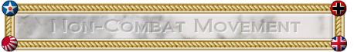

In the **Non-Combat Movement Phase**, the current player may move any or all of his units to the full limit of their remaining movement allowance, with certain exceptions.

* Air units must “land” in this phase. This means that they must end this phase in a territory that was controlled by the current player or an ally at the beginning of this player’s turn, or (for fighters only) in a sea zone containing an eligible friendly or allied carrier.
* Air units may not commit suicide or be dashed into the ocean. If still alive after the battle phase, all fighters must return to friendly land or move to carriers, or carriers must move to pick them up. Carriers have limited space, and may not be filled beyond capacity (in Big World and most other maps, Carriers have space for 2 fighters).
* Land and sea units that participated in any form of combat in this player turn may not move in this phase. Transports that unloaded this turn may not make any further movement.
* Units moving in this phase may not initiate any form of combat, including blitzing. That is, land and sea units may not enter any territory controlled by an enemy or neutral, or any sea zone containing an enemy or neutral unit.

Certain units, such as AA units, may move only in this phase, unless they are cargo in transports.

Transport rules still apply, and units can be loaded and unloaded in either combat or non-combat movement phases.

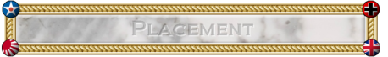

In the **Placement Phase**, units that were bought during the purchase phase at the beginning of this turn may be placed on the map.

Any newly purchased factories can be placed in any territory that was owned by the current player at the beginning of the turn. These new factories may not begin producing units until the next turn.

Generally, land and air units can only be placed in owned territories containing factories that were owned at the beginning of the turn.

Sea units can only be placed in sea zones that are adjacent to factories owned at the beginning of the turn.

If purchasing one or more Carrier units and 1-2 Fighter units per Carrier, then the Fighter units may be placed on the Carrier in the sea zone. In addition, when placing a new Carrier unit, you may move up to 2 Fighters from the adjacent factory-holding land territory, to the new Carrier unit. (However, in some maps you may not make this ‘free’ movement, and instead must move the Fighters there during the non-combat movement. In these maps you may also place new Fighter units on already existing adjacent Carriers.)

The maximum number of units placed at a factory in one player turn is equal to the production value of that territory. This includes sea units built in adjacent territories.

It is possible to place new units into sea zones controlled by an opposing player. This does not require combat resolution unless the situation persists until the end of the enemy’s next movement phase.

The exact procedure for placing new units is to left-click on an eligible territory or sea zone. At this point, a menu listing units available for placement there will appear. These menus may be closed and restored multiple times during the Placement Phase and changes can be made freely, all without penalty. After all available units have been placed, these menus will no longer appear, although “undo” is still available. Unit placements are listed on the right as they are made, and the placements can be undone at any time.

In a situation where several factories are adjacent to one sea zone, and a mix of land, air, and sea units are to be placed by each factory, the TripleA engine may not always calculate correctly which factory you wish to use to place the sea units. In this case, the land and air units should be placed first.

When all available units have been placed to the player’s satisfaction, he can manually terminate the Placement Phase by pressing “Done” on the right side of the screen. While there is usually no good reason to do so, a player is not forced to place all units before terminating this phase. Any units that were not placed are removed from the game (in some maps, the units may be retained and placed during the player’s next turn).

Newly placed units are fully functional at the end of this phase, meaning that they can be used for defending if attacked during the next player’s turn.

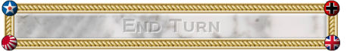

In the **End Turn Phase**, TripleA will automatically do all of the following actions, with no input required by the user.

1. Activate any technologies that were successfully researched during the Tech Development phase.
2. Count all of the income from owned territories and give that income to the current player.
3. If the map includes any bonuses for capturing certain objectives, these bonuses will be checked for and given out now. (As an example, a map may give an additional X pu’s for controlling a strategic territory, such as Egypt.)
4. In addition, any other end-of-turn effects occur. If a map has anything extra, it will list it in the Game Notes.

At the end of this phase, the next player may start their turn.

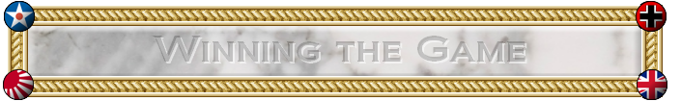

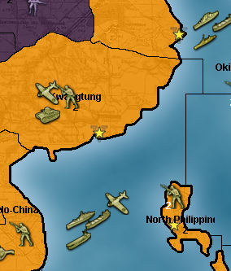

Normally “Victory” is determined by one player surrendering the game once they believe it is impossible for them to win. However, most maps, including “Big World” include default ‘victory conditions’, which the players can play too if no surrender is forthcoming. Normally victory is determined by controlling a certain number of strategically important territories, called “Victory Cities” (VCs), which are indicated on the map by small yellow stars. Depending on which victory condition is chosen during game setup, victory in “Big World” occurs when one side controls 14-17 victory territories (the default is 17).

The Victory Condition is normally tested at the end of every round.

Victory City marker: 

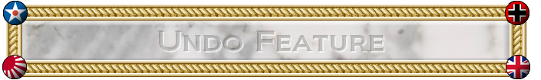

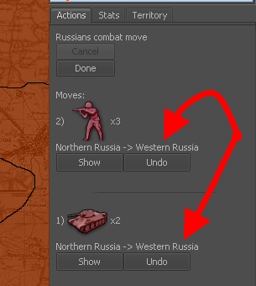

TripleA is a turn-based strategy game. Generally, this means that a player can spend as much time as he wants on any aspect of his move, and can freely change anything he does during the turn without penalty, until he manually ends a phase.

There are no time limits, though human players will generally appreciate faster play.

Live games, played on the lobby, network, or on the same computer (hot-seat), are generally played faster. Play-By-Email (PBEM) and Play-By-Forum games allow for much more time to consider and reconsider all actions.

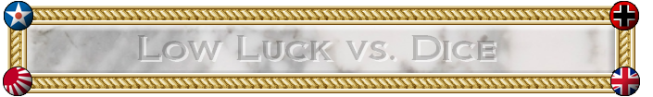

TripleA is a dice game, and as such there is a significant amount of luck present in each battle (though it will tend to even out over a long game, or series of games).

Since many players disdain the uncertainty created by the high variability of dice, we have created a system called “Low Luck” (LL).

In “Normal Dice”, one die is rolled for each unit participating in a battle.

In “Low Luck”, all of the attacker’s units have their attack powers added together. The total is then divided by the dice sides (6), and if there is any remainder it is rolled for. The defender does the same with the defense powers of all their units.

As an example, consider Germany using 4 armour to attack Russia, which is defending with 2 infantry plus 1 armour.

Round 1 of Battle:

Germany will take the attack power of each of her units and add them together. The total is 12 attack power (4 x 3).

This is then divided by 6, giving us 2 hits, and zero remainder.

Russia now selects 2 units to be allocated as casualties, and chooses her two infantry.

Now it is Russia’s turn to fire. The total for her is 7 defense power (2x2 + 1x3).

This is then divided by 6, giving us 1 hit, and 1 remainder.

Russia now rolls 1 die at 1, to see if she gets 1 more hit. We will pretend she misses for this example.

Germany now selects one of his armour to be a casualty.

Both sides now remove their casualties. Germany has 3 armour left, and Russia has only 1 armour left. Germany may now decide to retreat or keep fighting.

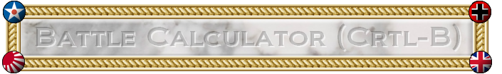

What is the expected outcome of this battle? How likely is it? These are questions that TripleA players, and wargamers in general, ask a lot, or at least they should.

Specifically, consider a turn 1 Russian attack into Finland in Big World.

In Finland, Germany has 2 infantry, each defending at 2.

The obvious starting point for this battle is Russia’s 3 infantry in Karelija. What are the chances of winning? How many more attack units should Russia add in order to win? There are 2 armour units nearby that could be used. If these are added, then the Russians have 9 total attacking power and 5 units (five hitpoints), while the Germans have 4 defending power and 2 units. This is obviously overkill, but can we be more scientific?

Assuming that Low Luck (LL) rules are in effect, the Russians will kill 1.5 units on round 1, and will probably lose one infantry. On round 2, if it happens, the Russians might lose a second infantry. Overall, the Russians will lose about one infantry but no more than two. Exact analysis shows that the Germans will get zero hits 5 times out of 18, one hit 11 times out of 18, and 2 hits 2 times out of 18. On average, the Germans will kill 5/6 of a Russian infantry on the first round, and possibly more if Russian’s miss their shots and the battle goes multiple rounds, so on average the Russians expect to have approximately 4 units remaining.

This calculation is relatively simple, but what if more units are involved? Fortunately, TripleA provides a handy utility called the Battle Calculator. It can be accessed through the Game menu, the Territory tab, or by hitting CTRL and “B” at the same time while your mouse is over the desired territory. It allows the player to calculate the expected outcome for any possible battle within the game, by simulating the battle occurring multiple times. If you use the CTRL-B shortcut while your mouse is over a territory containing a battle, then the battle calculator will automatically load the units in the battle.

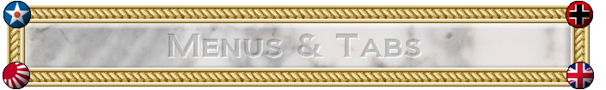

When a game is running, several menu options are available at the upper left of the screen, as well as three or more tabs just below the minimap on the right side.

Most of the menu options are either fairly unimportant or quite obvious in what they do. The most important non-obvious ones are described below:

* “Help -> Game Notes”. The ‘game notes’ are specific notes made by the person who made the map or mod you are currently playing. These notes often describe specific rules that this game variant follows, what each unit does, and any other things that the map maker thought important for you to know. It is definitely a good idea to read these before playing a map!
* “Game -> History”. By going to the ‘game history’ you can go back in time through all the steps to see each action that was taken by all players. By clicking on a specific round or step or action, the main screen will adjust to look just like the game looked like at the time when that action took place.
* “Game -> Edit Mode”. Edit mode allows you to perform actions that are normally illegal, or to adjust the game board in any way (like adding extra units, or deleting units, etc). The actions are recorded in the game history though.
* “View -> Show Map Details”. Map Details normally defaults to “true” when a map has them. Map Details (also called “reliefs”) is art that is shown on the game board. While normally visually pleasing, sometimes this art can cover up features you want to see, or make it hard to see who owns what territory. To view a map without art, and just see bare political boundaries, turn Map Details off.
* “View -> Map Skins”. Some maps come with multiple sets of art. You can switch between these art sets by selecting a different map skin here.

Tabs:

If the **Actions tab** is selected, then a list of all actions that have been ordered for the current phase is presented, and buttons are available to permit easy modifications. This can be considered the “default” tab.

If the **Stats tab** is selected, then important game information such as the income for each player, how many units each one has, and what technologies have been developed are listed. The players are listed in turn sequence.

If the **Territory tab** is selected, then moving the cursor over the map causes the contents and names of the map areas to be displayed below the minimap. (The names of the map areas and production values are displayed at the lower left of the main map widow at all times.) This can be very useful, especially for densely occupied maps where it can otherwise be hard to determine exactly what is going on in a given map territory. The Battle Calculator can also be accessed through this tab, but a player will rapidly learn that it is better to know the keyboard shortcut.

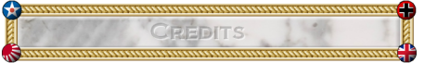

This manual and rulebook was created by:

* Victor Finberg (VictorInThePacific)
* Mark Christopher Duncan (Veqryn)

The art in this document was created by:

* Hepster

TripleA the game engine was originally created by Sean G Bridges, and was maintained by him until 2009 (TripleA version 1.2.5.5).

After 2009, the main developer has been Mark Christopher Duncan (Veqryn).

While many different things have inspired the creation of TripleA, and indeed as an open-source project we have many different contributors, one of the main inspirations has been Larry Harris, the creator of “Axis & Allies” (fully owned by Hasbro ®).

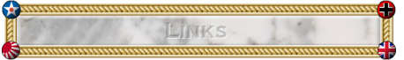

TripleA Downloads: <https://sourceforge.net/projects/triplea/files/>

Place to Report Bugs: <http://sourceforge.net/tracker/?group_id=44492>

TripleA Development Site: <http://triplea.sourceforge.net/mywiki>

TripleA Dev Forum: <http://triplea.sourceforge.net/mywiki/Forum>

TripleA Guides, Installing help: <http://triplea.sourceforge.net/mywiki/Guides>

TripleA Donation Page: <http://triplea.sourceforge.net/mywiki/Sponsors>

TripleA War Club: <http://tripleawarclub.org/>

War Club Forum: <http://www.tripleawarclub.org/modules/newbb/>

Axis And Allies .org: <http://www.axisandallies.org/>

AxisAndAllies.org Forum: <http://www.axisandallies.org/forums/>

Official Map Repository: <https://sourceforge.net/projects/tripleamaps/>

**Appendices & Additional Content are continued below…**

# Example of Play: First Turn Walkthrough of “Big World”

First of all, we have installed TripleA on the desktop of a PC and started the game. The setup window appears.

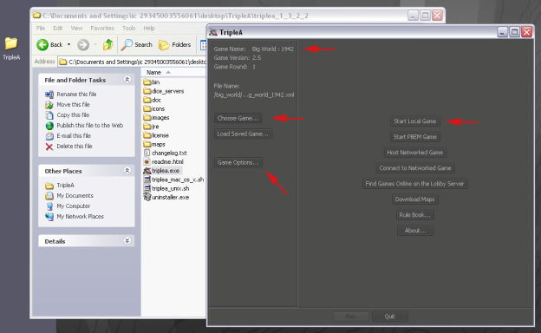

In order to begin this walkthrough, we must make sure that we are playing the correct game.

The “Game Name” in the upper left should read “Big World : 1942”.

If it does not, please click on “Choose Game…” and then select it from the menu.

In order to decrease the randomness, for the sake of tutorial purposes, we are going to change the game from its default of “Dice”, to “Low Luck”. You may also want to turn “technology development” off for now.

To do so, click on “Game Options…” and then make sure that the “Low Luck” checkbox is checked on.

Finally, we wish to start a local game (“local” means that all the players will use your computer to play). So click “Start Local Game”. (Even when loading games, you must choose a method of how to play them, either by clicking “Start Local Game” or “PBEM” or “Network” or “Lobby”. The savegames do not remember which method you used to start them, and this is intended.)

Now you must select who will be playing each of the nations. You will be playing as the Russians, so leave “Russians” as “Human”. If you are playing against a friend (perhaps by sharing the computer each turn, something called “hot-seat mode”), then leave the other nations as “human”. If not, you can set your opponents to be AI’s. We generally recommend playing against the “E.Z. Fodder” for your first time, and once you understand how to play, you can upgrade the challenge to “Moore N. Able”. The “Dynamix” AI is still being worked on, and as such it generally does not make any sea movements, and also may have bugs that crash the game. After selecting who will play each of the nations, click on “Play” in order to begin.

***The Game Begins…***

When the game starts, the map is focused on the main territories of Russia. You can use your mouse to scroll around the map (right click and drag the main map, or click or click and drag on the minimap). As you can see, the German front line has pressed all the way up to the main cities of Russia: Leningrad, Moscow, and Stalingrad. In addition, the Far East has seen the Japanese claim Port Arthur and Manchuria, putting masses of armies right on the border with Russia. Be sure to also notice Russia’s small fleet.

***Technology Research Phase***

We are given the option of spending resources on tech. Russia is both poor and under attack, so it is a good idea not to spend any money on technology. In the upper right of the screen, click “Done” to continue to the next phase. 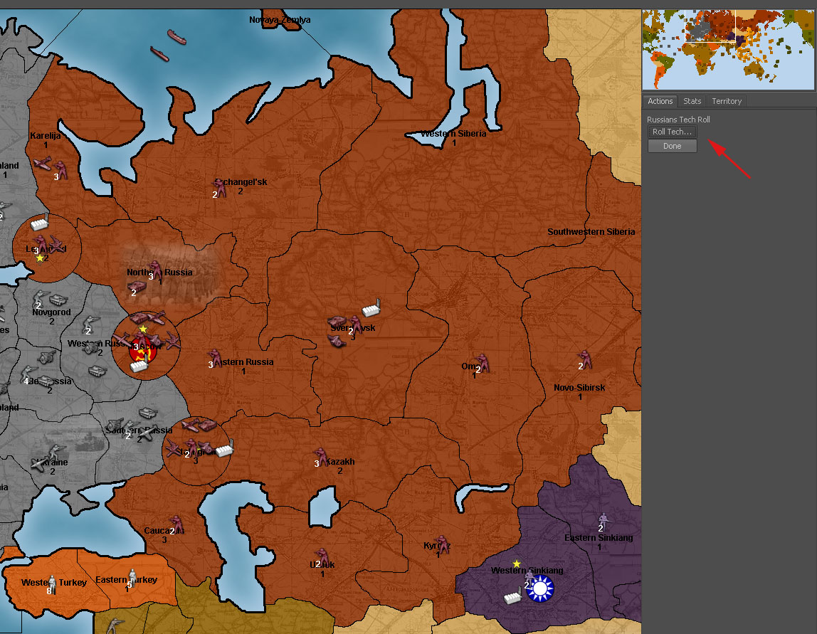

***Purchase Phase***

A production window will appear. Here you can see the basic stats of each of the units you can purchase, and for more detailed information, you can hold your mouse over a unit’s picture for a moment, causing a tooltip to appear.

Russia should buy mostly infantry for a very long time, as they are the most cost-effective defenders and the cheapest units. In order to counter-attack, you will need to rely on artillery and air power. Armour is a bad buy because it is subject to destruction on counter-attack. 10 infantry + 1 artillery is a reasonable first-turn production (other reasonable purchases are 7 infantry + 2 artillery + 1 tank, or 8 infantry + 1 fighter). 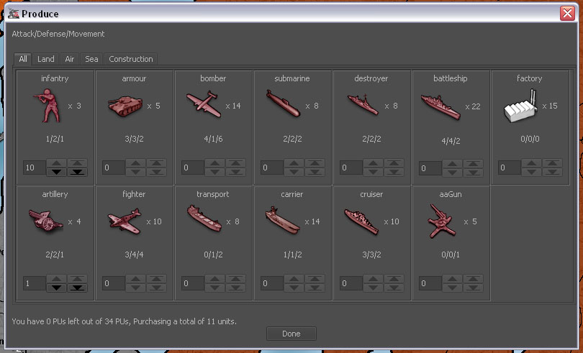

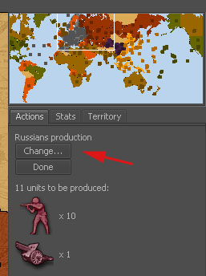

If you click “Done” on the production window before you are really done, do not worry, as you can still change your purchase as long as you have not yet clicked “Done” on the right-side panel. Russia has 4 factories, and only 3 are on the front line. Adding up the values of each territory where you have factories, you see that you can produce no more than 12 units per turn, of which 9 could be on the front line with Germany and 3 further back. Supposing you decide that you want to produce fewer units, because the front-line factories can only produce 9 units total. So let’s produce 7 infantry, 2 artillery, and one armor instead (click “Change…” to do so). When finished, click “Done”.

***Combat Movement Phase***

In the Far East, you notice that you can attack Northern Manchukuo with a total of 5 infantry (5@1), against a total of 2 infantry (2@2). If you were playing with “normal dice”, this would be a risky attack that most commanders would avoid even though you have a good chance of success. Since we are playing using “low luck”, this battle would be easily won with near-certainty.

However, as a commander, you need to look ahead not just to the end of your battles, but to what might happen on the opponent’s turn, and maybe even beyond that. If you attacked Manchukuo, your infantry forces (representing about half of your total Far East forces) would be left exposed to a devastating counter-attack, especially since Japan has significant air capabilities. With half of your forces wiped out, you would be forced to give up much of the Russian Far East. Because of this, we choose not to attack, meaning no combat movements are needed in the East for Russia.

On the Western Front (from the Russian perspective), we will crush the Germans wherever we can. It is important not to let Germany get close to your factories, so we must push them back. We will conquer 4 territories and try for one submarine.

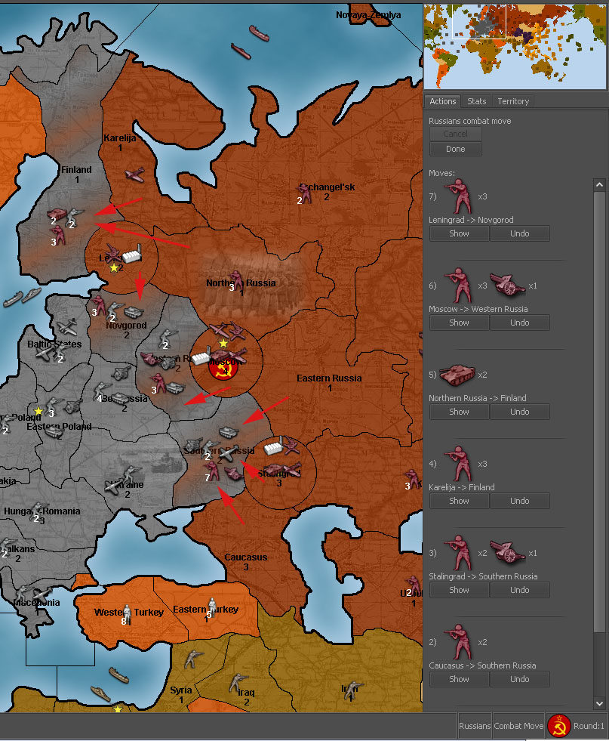

We will attack Southern Russia with all the adjacent infantry and artillery that can’t attack anywhere else. We have 7 infantry and 1 artillery (10 attack power) and 8 hitpoints VS. 13 defense power and 5 hitpoints (2 infantry, 1 artillery, 1 armour, 1 fighter). This battle strongly favors the Russians because of our advantage in hitpoints.

We will attack Finland with 3 infantry from Karelija and 2 armor (9 attack power and 5 hitpoints VS. 4 defense power and 2 hitpoints). This is an easy win for Russia, and our tanks cannot easily be counter-attacked since Finland is separated from the German reserves in Eastern Europe.

We will attack Novgorod with 3 infantry from Leningrad and we will attack Western Russia with 3 infantry + 1 artillery from Moscow.

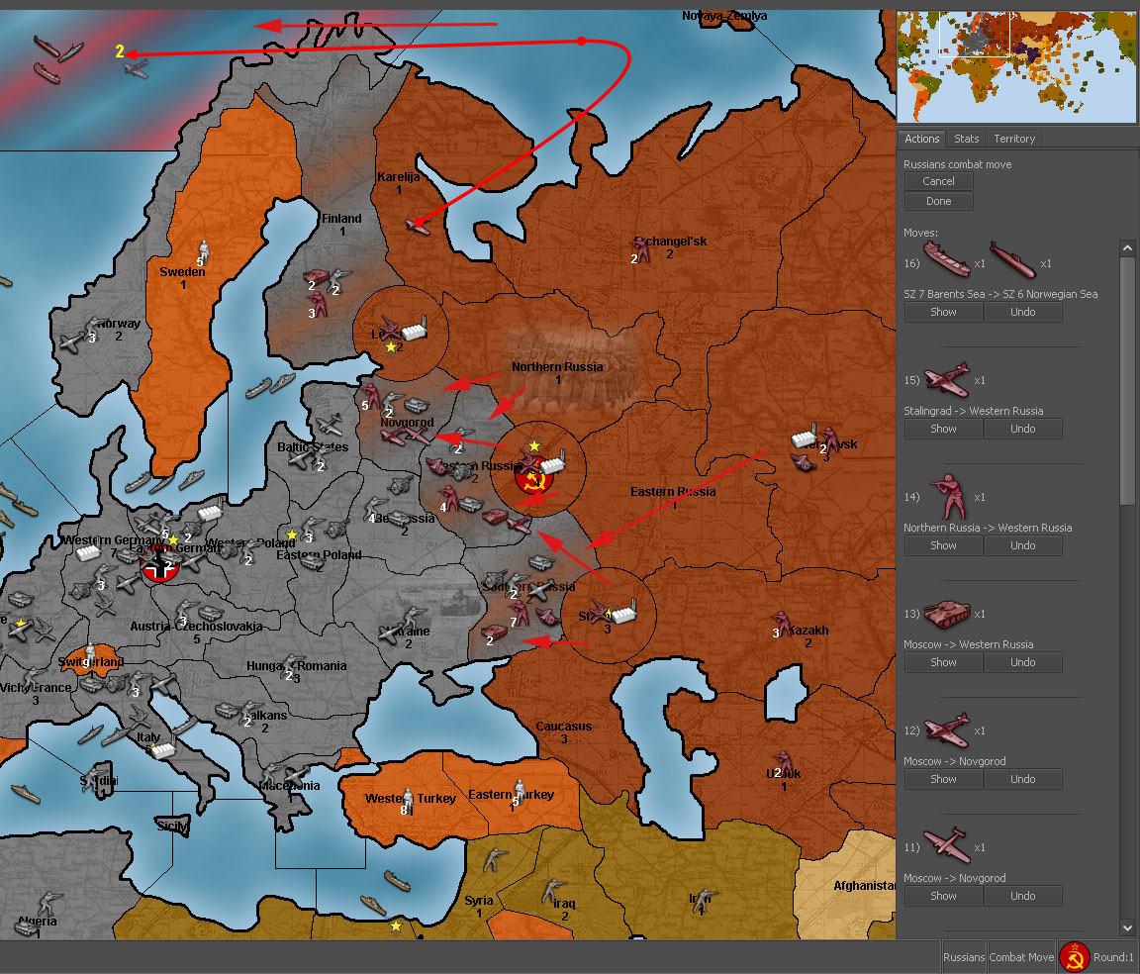

At this point, we still have more forces to commit, and it looks like we can take out one submarine as well.

We throw 2 tanks into the S. Russia battle, because we want lots of troops left there, so it will be difficult to counter-attack them.

We add 2 infantry, a bomber, and a fighter to the Novgorod battle, to ensure that we win it.

We add a fighter, an infantry, and a tank to the W. Russia battle, since we would prefer to not take so many casualties in this battle. (Generally speaking, the longer a battle goes on, the more casualties the defender will cause to the attacker. The attacker should aim to destroy the defender in as few rounds as possible.)

This leaves the entire Russian navy plus one fighter to take out one German submarine.

Destroying the submarine is important because it helps to protect the British navy.

This is a really strong Russian offensive, and it may not be the best possible Russian Turn 1, but we will leave it to you to figure out a better strategy. We now end this phase by clicking “Done”.

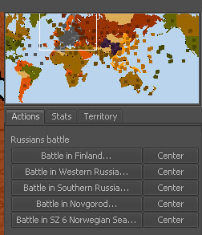

***Battle Phase***

We have 5 battles, which we can resolve in any order we wish. Generally speaking, it is best to resolve the ‘most critical’ battles first; that way we can decide if we need to retreat from other less critical battles, or choose casualties in a specific way. However, for this example play-through, we will just go down the list. To start a battle, just click on the buttons on the right side (and to show where a battle is, click on the “Center” button).

1st Battle: Finland

Here we have the Russians with 3 infantry (rolling @1), and 2 armour (rolling @3). The Germans are defending with 2 infantry rolling @2. You can see what number each unit is rolling at by looking at which column it is in.

For our battle, the Russians have a total of 9 attack power, meaning that using Low Luck the Russians will automatically get 1 hit, and will roll a die @ 3 to determine if we get 1 more hit or not. (9/6 = 1, with 3 remainder).

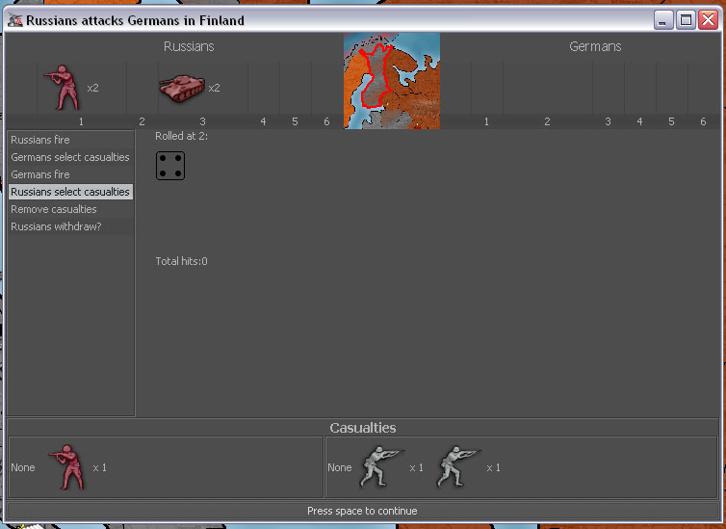We roll a 5, meaning we miss the chance for the second hit.

Now the Germans have their chance to roll. With a total of 4 defense they get no automatic hits, and must roll a single die at @ 4 to determine if they get any hits. (4/6 = 0, with 4 remainder).

The Germans roll a 3, meaning they hit us.

We choose to lose one of our cheapest units, an infantry. Since we still have great odds, we choose to continue the attack.

On round 2 of the battle, we kill the remaining German infantry.

The Germans get to shoot back though, but they miss their roll by getting a 4 when they needed a 1 or 2.

The end result: the Russians lose 1 infantry, while the Germans lose 2 infantry. The Russians now conquer Finland (and Finland turns red to show this).

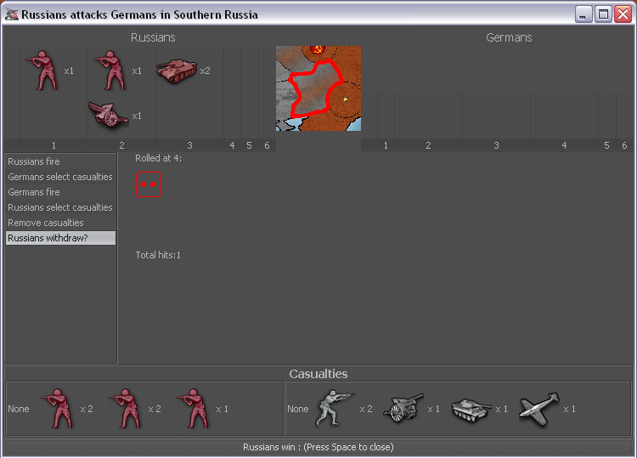2nd Battle: Southern Russia

This battle does not go as well for us as we had hoped for, but we still manage to win.

The Russians lose 5 infantry, but the Germans lose all of their units, including an expensive fighter.

3rd Battle: Novgorod

In Novgorod we win handily, losing only one infantry. We have 4 infantry and 1 bomber and 1 fighter left.

4th Battle: Western Russia

Here Russia wins, losing 2 infantry. We are left with 2 infantry, 1 artillery, 1 armour, and 1 fighter.

5th Battle: Norwegian Sea (Sea Zone 6)

In this battle, the two submarines fire first. Unfortunately ours misses, and the German’s hits. We take a transport casualty. After this, our fighter rolls, getting a hit and killing the German sub.

If our fighter had missed, the German submarine would have a chance to submerge, effectively ending the battle. (The AIs almost never submerge, but human players do.)

In all the combat resolutions, just use common sense, and mostly do what the game tells you to do. The battles pretty much play themselves. Sometimes, you may wish to choose different casualties than the engine suggests, and often you must make a hard choice about whether to retreat or continue.

***Non-combat movement***

First, we must “land” all of our aircraft. The fighter that attacked the German submarine should land in Karelija. The 2 other fighters land in Leningrad, and the bomber lands in Moscow. Defending Leningrad with fighters, especially British fighters, is key to Russian survival. Russia must hold onto Leningrad for as long as possible, and fighters defend at 4, making them very good at this when backed up with sufficient infantry.

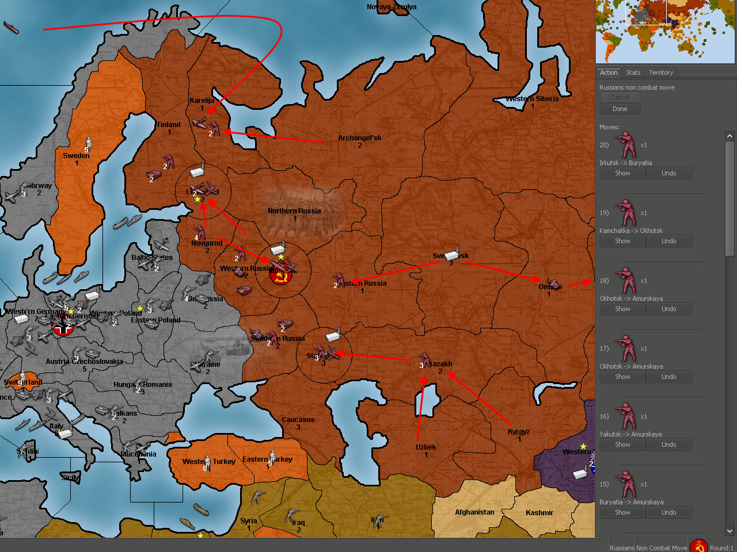

In the middle, all the Russian infantry heads for the German front. The single artillery in Sverdlovsk, and the 2 infantry in Omsk, will head to the east to provide some attack power in case the Japanese get greedy.

In the East, send all of your units to meet in Amurskaya. Continue to move them each turn, and watch how strong the Japanese are. If the Japanese get too strong, or have enough aircraft in the area, you may be forced to move back to Buryatia in order not to lose your forces.

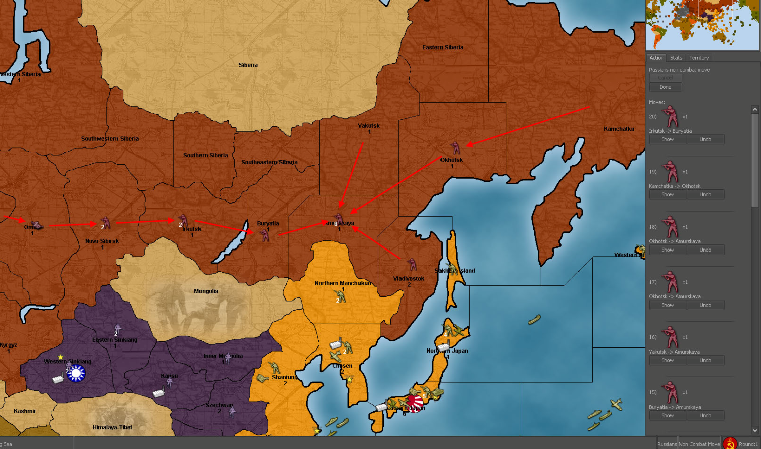

When you are ready, end the phase by clicking “Done”. If you should forget to land a plane, you will be told. If this happens, you can force the plane to commit suicide or you can go back and continue making moves.

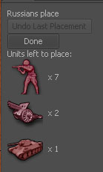

***Unit Placement Phase***

In order to place the units that you have purchased, you must ‘left click’ in any or each of your territories that contains a Factory or unit which has the ability to produce other units. To place sea units, you must click in a sea zone next to a territory containing a factory unit.

You have a total of 10 units to place: 7 infantry, 2 artillery, and 1 armour. We start by placing units in the most important territories.

Click on Leningrad, and use the menu that appears to place one infantry and one artillery there.

Click on Moscow, and place 4 infantry.

Click on Sverdlovsk, and place the armour there. This unit can use its extra movement to reach either front quickly.

Click on Stalingrad, and use the ‘max’ button to place the remaining 2 infantry and 1 artillery there.

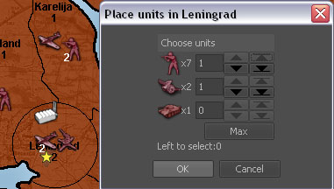

When finished, hit “Done”, and the Russian turn will end. The TripleA Engine will calculate your total production for the turn by adding up all the territories owned by Russia, and give you that many PUs. Because of our attacks, Russia receives 41 PUs this turn.

Now the German player begins their turn.

***Analysis of the luck factor for Russian turn 1***

The low luck system can make battles more deterministic (less luck-dependent), but at the cost of removing some of the risk and changing how the game is played. Basically, every 6 firepower points guarantee one hit, and you only roll for the remainder. But you still have to set up the battles to make the system effective. For example, a battleship-on-battleship encounter is completely random, and the swing is huge. But a bomber plus two infantry attacking a fighter under low luck rules guarantees that the fighter dies in one round, taking a maximum of one infantry with it. Sending a bomber plus 1 infantry leaves this battle up to luck completely, while sending 1 bomber plus 3 infantry is unnecessary since you only need 1 hit to kill the single enemy fighter.

Most of the Russian attacks in the Example of Play are easy to analyze, especially because using lots of low-firepower units means that their combat value degrades very slowly. Accordingly, the details are left to the reader.

Norwegian Sea: 3 + 2 sub + 0 vs. 2 sub; expecting 0-1 loss; lost 1

Finland: 3 x 1 + 2 x 3 vs. 2 x 2; expecting 1 loss (1.5 rounds); lost 1

Novgorod: 5 x 1 + 2 art + 2 x 3 vs. 2 x 2 + 3; expecting 2 losses (2 rounds); lost 1

W. Russia: 4 x 1 + 2 art + 2 x 3 vs. 3 x 2 + 3; expecting 2.5 losses (2 rounds); lost 2

S. Russia: 7 x 1 + 2 art + 2 x 3 vs. 3 x 2 + 3 + 4; expecting 3.5 losses (2.5 rounds); lost 5

Overall, Russia lost just a bit more than expected, but nothing out of the range of general variability.

Remember that if you make 20 attacks, each of which has a 95% chance of winning, on average you will lose one of those attacks. Just because the Battle Calculator says that you have a 95% or even 99% chance of winning, doesn’t mean you should not prepare for the possibility of losing that battle.

***Strategy analysis***

Germany’s primary turn 1 objective is to at least cripple the British navy. After that, the British concentrate their ships and cause the Germans no end of trouble. Russia must do what it can to help the British on turn 1. Therefore the primary Russian objective on turn 1 is to exert maximum pressure against Germany, while building up defense forces against the coming retribution. After turn 1, it becomes Britain’s primary responsibility to do everything it can to help the Russians.

We can see that Germany cannot effectively attack both the British navy and Russia, because they have only so many aircraft, so by forcing this choice either the Allies will have plenty of time to build up a defense of Russia, leading to a long-term Allied win, or the British maintain their fleet, which may lead to an early Allied win.

In the Far East, Russia puts on a strong immediate defense, which can be converted to a good delaying action. Considering that Britain and China move before Japan, the Japanese will have great difficulty expanding in Asia for a long time, which gives the Americans time to build up.

TripleA

Tactical Handbook

By Pulicat

*Version 1.0*

This is not a strategy guide. Strategy involves the setting goals and priorities, and deciding where and when to attack and defend, as well as what units to buy. There are plenty of articles written already about the strategies for various maps in TripleA. This handbook seeks only to describe the tactical tools one can use to achieve those goals and priorities that are essential to strategy. Some of the scenarios described below may not be realistic during actual gameplay and are contrived for illustration purposes only. All screenshots are from “Pact of Steel” or “World War II Revised” (also known as WW2v2).

Setting Objectives

Every move and decision made should be made with clear objectives in mind—moves without clear objectives are unnecessary and will cost you valuable tempo. In TripleA, tactical decision-making essentially boils down to two categories: where and how to attack, and where and how to defend. In order to better make these decisions, an understanding of the purpose of attack and defense is needed.

The Objectives of Attack

A player may attack for any one or combination of the following reasons:

* **Taking production.** Each territory captured has a production value which contributes to your income at the end of that turn. If this is the sole objective of an attack you’re considering, then only a simple risk-benefit analysis is needed to determine whether the territory is worth the potential casualties you’ll suffer in battle.
* **Destroying enemy units.** Often, a player does not care about the worthless production value of a territory at all and seeks only to annihilate an army located on that territory, to cripple and weaken the enemy. In this case, whether or not the attacker successfully captures the territory is irrelevant, as long as the enemy army is destroyed or nearly destroyed. Usually, a player does this when he can be sure of a favorable kill-to-casualty ratio so that he will have dealt more damage to the enemy than what he suffers himself.

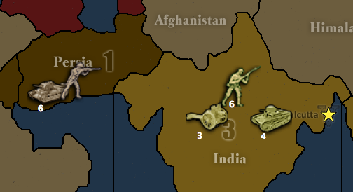 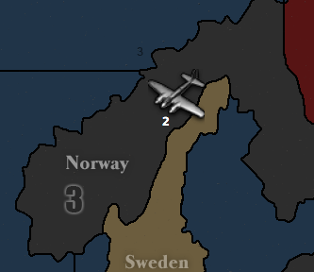

*Fig. 1.* The Japanese player decides to attack Persia with the entirety of his Indian army. He has no interest in Persia itself—he only wants to destroy the British tanks there. In this battle, the Japanese player can be very certain of a favorable kill-to-casualty ratio. The British have only 1 infantry with the army so any casualties taken after the first one will eat directly into their stack of tanks. The Japanese, on the other hand, have plenty of cheap infantry fodder to absorb casualties and can easily destroy the expensive British tanks at a low cost. Most likely, the Japanese will be able to destroy the British 1 infantry and 6 tanks at a cost of perhaps 5 or 6 infantry—a very good deal! If the Russian player has a large stack to attack Persia if Japan were to win, Japan can retreat back to India after one or two rounds, having dealt Britain a crippling blow, perhaps leaving Britain with only 1-2 tanks at a cost of only a couple infantry.

*Fig. 2.* The German player has made a terrible blunder by landing his 2 bombers in Norway without sufficient defense. The Allies now have a very strong incentive to attack and destroy the expensive German bombers. The bombers defend at only 1 and are sitting ducks to any land, aerial, or amphibious attack.

Alternatively, a player with more resources and production may choose to throw attacks at the enemy regardless of the kill-to-casualty ratio in an effort to wear down the enemy, relying on the fact that they can afford to replace their losses but their opponent cannot. This is the equivalent of the real-world human wave attack.

* **Area control.** This refers not to the physical possession of a territory, but the ability to project influence over an area. A player who gains control over an area gains the initiative and the ability to make a wide range of tactical and strategic choices, giving him the power to maneuver the enemy and fight battles on his own terms.

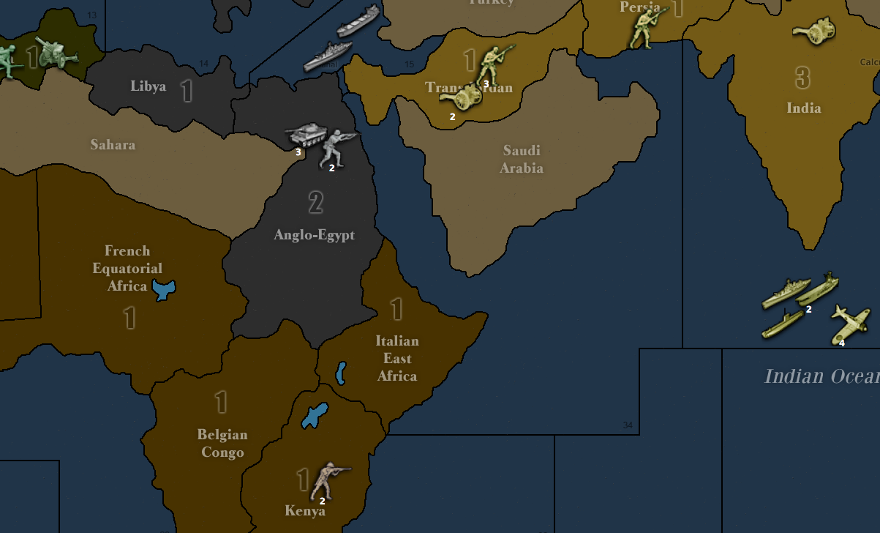

*Fig. 3.* Germany has just captured Anglo-Egypt. Germany has seized the initiative by gaining two great types of area control: 1) Control of the Suez Canal, which allows the Japanese fleet off the coast of India to join the German fleet in the Mediterranean. 2) Access to the lightly-defended interior of Africa, which Germany can quickly capture with its tanks and infantry at no cost.

* **Area denial.** Taking control of an area means the enemy correspondingly loses control there and is forced on the defensive. The enemy loses tactical flexibility and options and is forced to respond to your actions instead of taking initiative of his own.

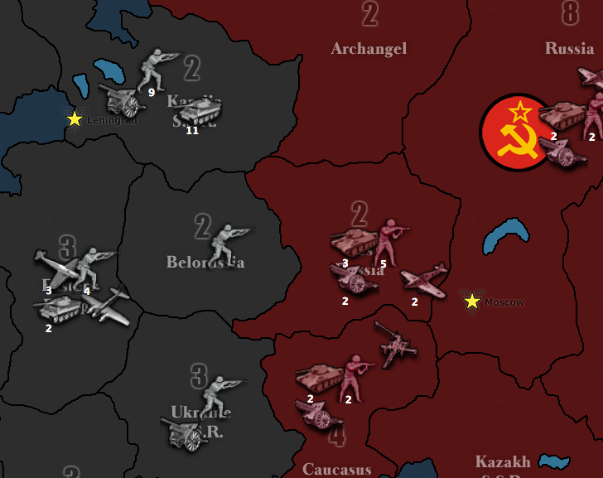

*Fig. 4.* Germany has just seized Karelia with a large army and now stands facing a weaker Russian army in West Russia. Even if Russia counterattacked Karelia with everything that can reach it, he has almost no chance of destroying the stack of 11 German panzers and will suffer unacceptable casualties. If the Russian army stays in West Russia, it risks being annihilated on Germany’s next turn when Germany can bring to bear an overwhelming force of 11 infantry, 2 artillery, 13 tanks, 3 fighters and a bomber against West Russia. Russia has lost control of the area and is forced to retreat to either Caucasus or Russia or else suffer crushing defeat. Since the German move to Karelia denied Russia the ability to safely field any significant armies in the area, Germany can now trade and maneuver Archangel and West Russia at his leisure.

* **Diversion.** Often, diversionary tactics are needed to draw attention away from a hard-pressed ally or a collapsing front. These include amphibious landings and unexpected attacks along the periphery. Sometimes, an actual diversion is not needed—just the *threat* of a diversion suffices. For example, the threat of a D-Day invasion posed by a looming Anglo-American fleet in the Atlantic is often enough to cause the German player to divert units from the Eastern Front to defend France.

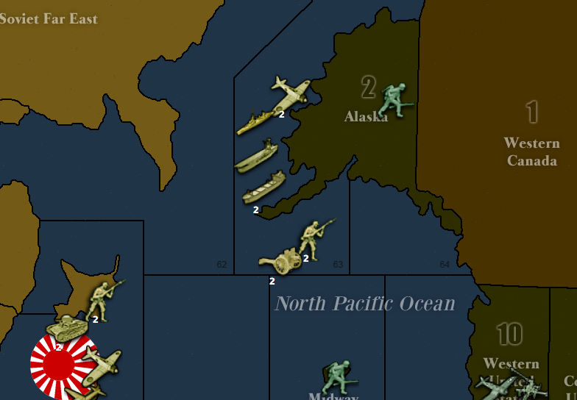

*Fig. 5.* Japan makes a diversionary landing in Alaska to draw American attention away from Germany.

The Objectives of Defense

There is a symmetry between the objectives of attack and those of defense. A player’s defensive tactics may be influenced by any one or combination of the following reasons:

* **Denying production.**
* **Wearing down the enemy.**
* **Area control.** Like seizing area control, holding on to critical control of an area is the most common motivation for mounting a defense.

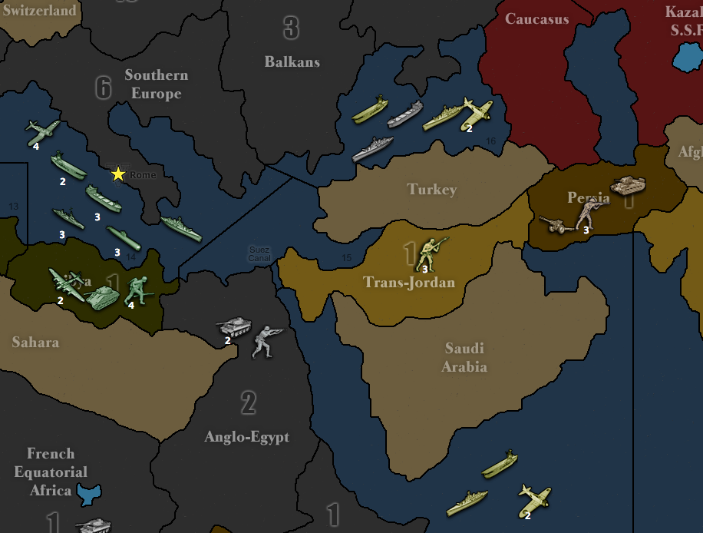

*Fig. 6.* The Axis have a strong incentive to vigorously defend both Anglo-Egypt and Trans-Jordan to keep the Suez open so their two fleets can combine. Otherwise, the American fleet off the coast of Southern Europe can annihilate the Axis fleets piecemeal.

* **Area denial.**
* **Bait.** Sometimes, a player may deliberately leave an area weakly defended or intentionally provide an inviting target in order to induce the enemy to attack. This can either be a diversion of sorts, to draw the enemy away from a critical theater, or a bait leading to a trap.

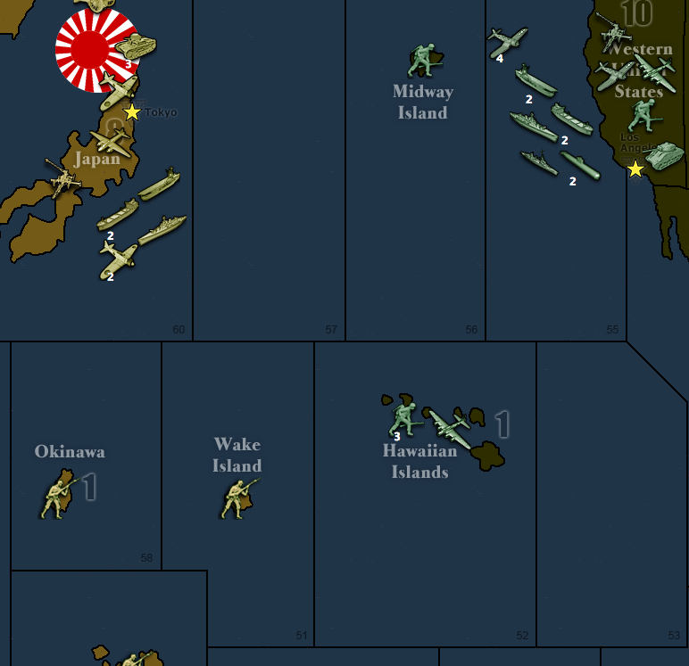

*Fig. 7.* The American player has landed an expensive bomber in weakly defended Hawaii, presenting a juicy target highly vulnerable to amphibious assault. The US is hoping that this will entice Japan to commit transports and fighters from off the coast of Japan into Hawaii. If Japan commits fighters, he will also need to send his carrier into the sea around Hawaii to pick up the planes. Lots of American ships and planes lurk on the West Coast, waiting to crush the Japanese fleet should he fall for the trap.

Tactical Concepts

**Concentration of force.** This one is pretty intuitive—you want to be able to concentrate your strength at one point in order to make breakthroughs, win critical battles, and hold important ground. While you don’t need to concentrate your firepower for every single move you make (that would probably be disastrous), you should always keep in mind the iron rule: A concentrated force is *always* stronger than the sum of its parts. This rule applies to your opponents as well, so you should look for ways to prevent the enemy from concentrating his forces in order to have them **defeated in detail**.

The more powerful the army you bring to battle, the lower its casualties will be. This is because if it takes a few rounds of dice-rolling to kill all enemy units, then the enemy would have had a few rounds of combat to fire back at you. If you overwhelm the enemy and wipe them out in just one dice roll, then they will have had only one chance to fire back, inflicting fewer casualties on your army. The longer a dice battle goes on, the more rounds the dice battle has, the more casualties the defender will inflict on the attacker.

**Cannon fodder.** Battle entails casualties, and you will always need cheap, expendable units to absorb hits, or else you will lose your more expensive and valuable units. On land this means infantry, at sea this means transports or submarines (or submarines and destroyers in newer maps). Providing sufficient infantry cover is essential to both offense and defense, so never forget to purchase enough infantry. Let’s revisit the situation in Figure 1. The Japanese in India would have had a far more difficult time trying to destroy the British army in Persia if the British had more infantry as cannon fodder to absorb hits, thus allowing their more powerful tanks to survive and strike back heavily against the invading army. In Figure 2, Germany could have easily deterred any small-scale raid against their Norwegian bombers by sending some infantry cover. Any Allied effort to destroy German bombers covered by, say, 5 infantry would require far more commitment of resources. Often, battles of annihilation are fought because the attacker believes he has enough of an infantry advantage to **out-fodder** the enemy.

**Counterattack.** For every attack you make, you should consider whether the enemy has the ability to counterattack and destroy your survivors on his turn. Likewise, you often want to have the ability to make a swift and crushing counterattack in order to discourage the enemy from making any deep penetrating moves.

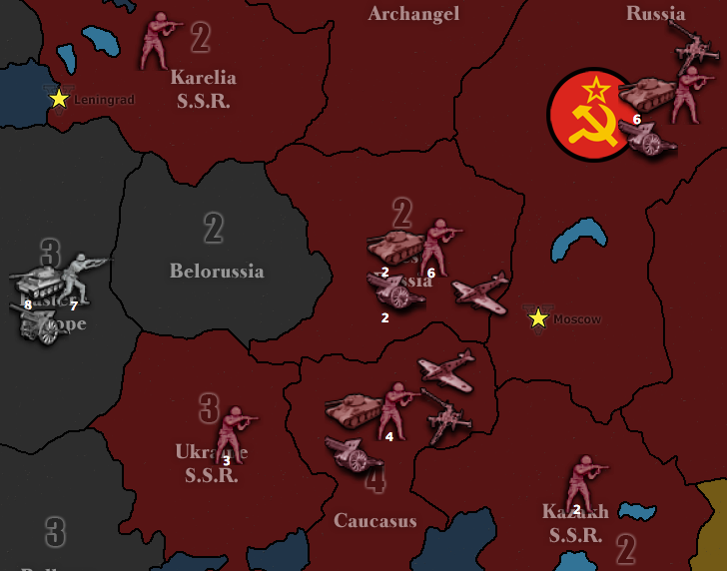

*Fig. 8.* Germany is trying to decide whether or not to attack Ukraine with his entire army in Eastern Europe (white), thus putting great pressure on Caucasus. He can take Ukraine without a problem and expect 1-2 casualties, but realizes that his army, once moved to Ukraine, could be subject to devastating Russian counterattack (red). The Russians have the ability to attack Germany’s army in Ukraine with 10 infantry, 3 artillery, 9 tanks, and 2 fighters, which is an overwhelming force that will probably destroy the German army. Unwilling to take the risk, Germany decides to take Ukraine with only the minimum force needed, rather than moving his entire army to Ukraine.

**Blocking.** Tanks and naval units move 2 spaces at a time, and “blocking” refers to using expendable fodder units such as infantry or submarines to slow or limit their movement.

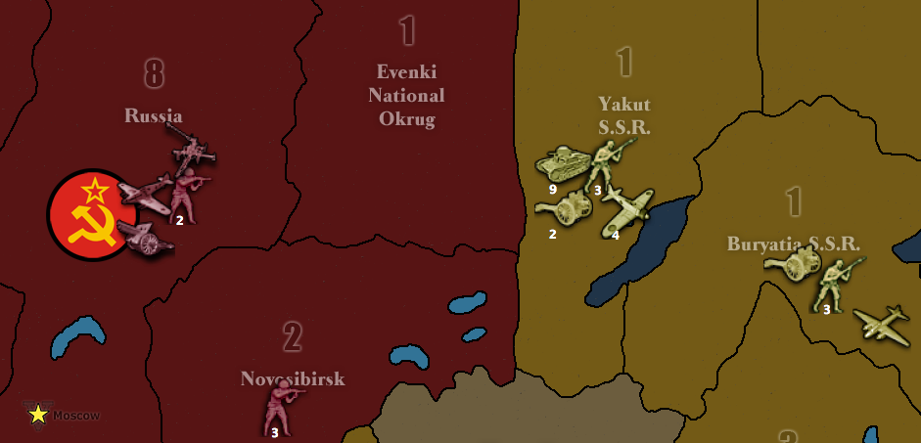

*Fig. 9.* It is Russia’s turn and he is facing a serious situation. The Japanese build-up in the eastern Soviet Union has reached a culminating point and Japan is about to push hard for Moscow. Russia is going to build 6 infantry and 2 artillery in Russia, but Japan still has very good odds of capturing Moscow by blitzing to Russia with his 9 tanks supported by 4 fighters and a bomber (yellow). Russia can send 1 infantry from Novosibirsk to Evenki as a sacrificial roadblock to prevent the tank blitz (red), thus buying time for 1 more round of building and preparation for the final showdown.

**Active defense.** This category of defensive actions involve the seizing of ground or using aggressive attacks as a means of defense, and includes airfield denial, block attacks, and strafing. This is contrasted with passive defense, which involves hunkering down with lots of units and waiting for the big battle.

**Airfield denial.** Air units need places to land, but can only land on territory that has been in possession for a full turn—presumably this rule simulates the time it takes to construct airfields. By capturing potential landing spots, a player can deny enemy air units areas over which they can operate.

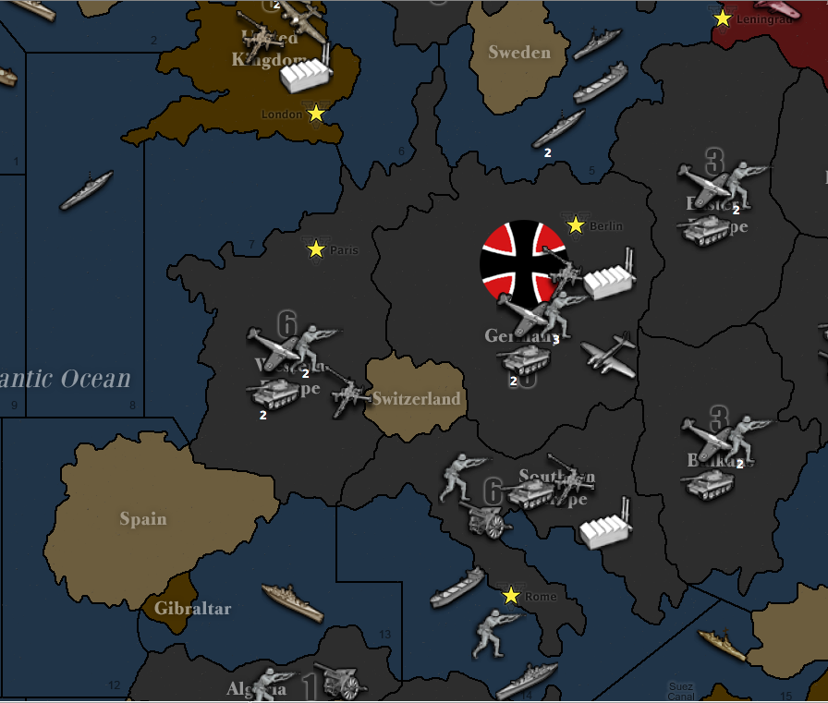

*Fig. 10.* A common German opening involves killing the British battleship in Sea Zone 13 with the Atlantic submarine, Italian battleship, and 4 or 5 fighters from all over Europe, coupled with the landing of an infantry on Gibraltar in order to protect the German ships from British counterattack. If the Germans do not seize Gibraltar, then the British could make an aerial attack on the weak German fleet gathered at Sea Zone 13 with 2 fighters and a bomber based in London. With the capture of Gibraltar, such attack is not feasible because the London fighters will have no place to land—and sending just the bomber would be suicide.

**Aerial block attack.** Often, it is not possible to simply send a fodder unit as a roadblock—the territory you wish to block is occupied by enemy troops. If you still wish to set up a block, you need to attack with sufficient force to kill the enemy units and still have enough survivors to block the space. Sending tanks and artillery along with infantry into a blocking battle is often a poor choice because the remaining units will be destroyed in the enemy’s counterattack, and the whole point of blocking is to conserve your forces, not let them be defeated in detail. This is where the air force comes in handy, because air units provide offensive firepower but fly back to land behind the front lines instead of remaining exposed to counterattack. Two fighters and two infantry do the same work as two tanks and two infantry, except that unlike tanks, they will not be sacrificed as blocking fodder. Fighters and bombers are therefore essential to capturing territory with economy of force.

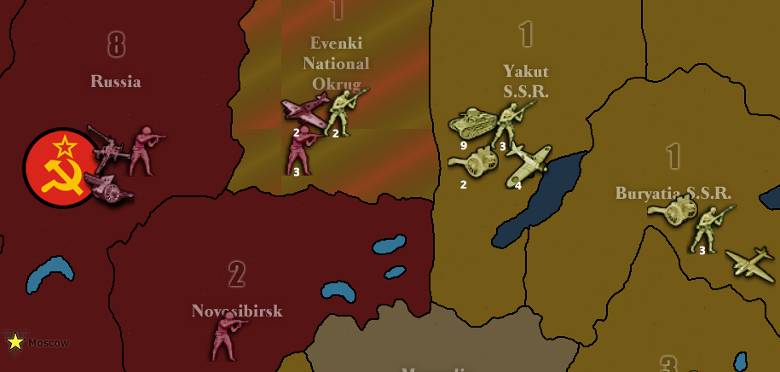

*Fig. 11.* Russia faces a similar situation as in Fig. 8, except Evenki is occupied by 2 Japanese infantry. Russia sends 2 fighters and 3 infantry to capture and block Evenki. In battle, one Russian infantry is killed and the remaining 2 stay in Evenki to block the Japanese blitz. The Russian planes fly back and land in the safety of Moscow.

**Trading.** Often, two players do not want to commit large forces against each other and are content to take turns making blocking attacks against each other, trading territory back and forth. Trading serves the dual purpose of blocking enemy movement and capturing territory production, and is a form of attritional warfare. Trading usually favors the player with the superior air force which can launch more aerial blocking sorties. Since fighters cannot land on newly captured territory (presumably to simulate the time it takes to prepare airfields), trading also serves the purpose of denying the enemy forward air bases from which to operate.

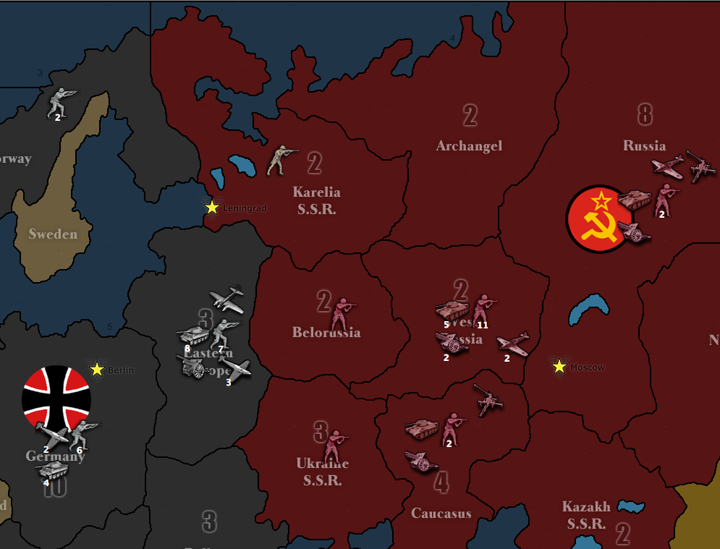

*Fig. 12.* Situations like this one is common for the Eastern Front and features Germany and Russia trading territory with each other. In this situation, Russia has just blocked Belorussia and Ukraine, with the UK helping block Karelia. Germany will then launch aerial blocking attacks against those territories, and the process repeats until one side cannot keep up with the rate of attrition or becomes distracted by a second front.

**Infantry/artillery coordination.** Each artillery unit has the ability to boost one infantry unit’s attack from 1 to 2. The presence of a few artillery pieces in an infantry mass is an extremely cheap way to boost offensive power—for the additional 1 IPC you spend on purchasing an artillery instead of an infantry, you are essentially purchasing 2 attack points: 1 for the artillery, which attacks at 2, and 1 for an infantry the artillery supports, which also attacks at 2. Bringing artillery into battle is highly effective weapon that should be used all the time. However, for greatest effect, you should always start battles with more infantry than artillery, to ensure that killing your infantry fodder will not decrease the supporting effects of artillery. For example, let’s say you fight a battle with 10 infantry and 5 artillery. The 5 artillery and 5 of the infantry attack at 2, and the 5 remaining infantry attack at 1. As long as the casualties you accumulate do not exceed your fodder of 5 infantry, you will get to keep rolling 5 artillery and 5 infantry at 2 for several rounds of combat.

**Strafing.** Sometimes, a player does not wish to occupy a territory, and seeks only to slaughter enemy units at a favorable kill-to-casualty ratio. Strafing is when a player attacks only to fire once or twice before retreating from battle. This sort of hit-and-run tactic is particularly effective when you have achieved concentration of force but the enemy has not, so you are able to inflict defeat in detail.

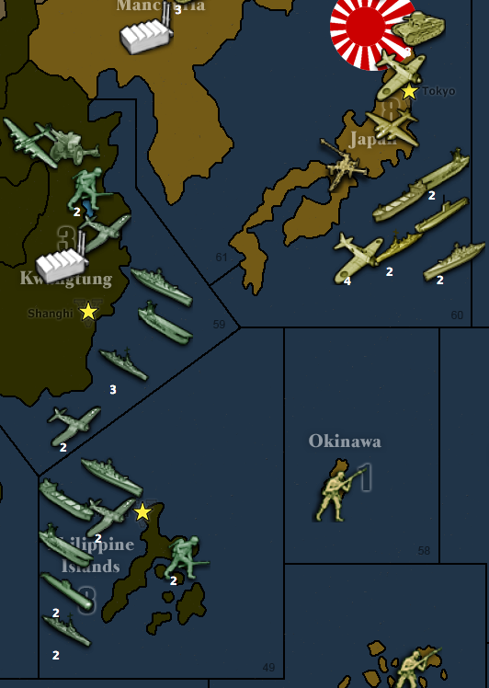 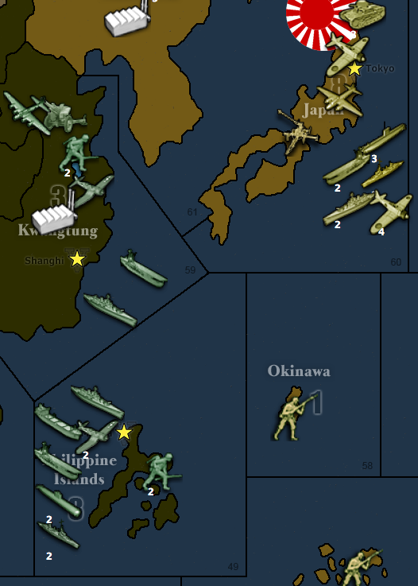

**…and run**

**Hit…**

*Fig. 13.* It is Japan’s turn, and the US has gathered an impressive navy and poised to wipe out the Imperial Japanese fleet and begin invading the home islands. On the Americans’ turn, they can concentrate an overwhelming force of planes and ships against the Japanese fleet and will annihilate it for sure. However, the situation is not as hopeless as it seems—the Americans are not concentrated yet, so this provides the Japanese with a window of opportunity to conduct a hit-and-run strafe to weaken the Americans and defend the home islands. The Japanese attack the American fleet in Sea Zone 59 with everything they’ve got (2 battleships, 2 destroyers, 2 aircraft carriers, 5 fighters, 1 bomber, 1 submarine, 1 transport). In the first round of combat, the Japanese score 6 hits; the Americans absorb one hit with their battleship and kill off 3 destroyers and 2 fighters. The Americans fire back and score 4 hits; the Japanese absorb 2 with their 2 battleships, and sacrifice the transport and a destroyer. After one round of combat, the Japanese happily retreat back to where they came from. They have killed 5 American units worth a total of 56 IPC at the cost of 2 units worth 20 IPC. In addition, the Japanese builds 2 submarines to reinforce their fleet, and the Americans have lost their overwhelming advantage and the chance to easily wipe out the Japanese fleet. Note that this tactic counted on the fact that the Japanese fleet did not wipe out the American fleet during the first round of combat. If the Japanese had rolled any luckier and wiped out the Americans completely, they would not have been able to fall back and get reinforced by their submarine build.

**Aerial strafing.** Air units are ideal for strafe attacks since they do not stay to exposed to counterattack regardless of whether they win the battle or not, and instead fly back to fight another day. Naval powers like UK, Japan, and USA can build up a powerful naval-air combined force that can terrorize enemy shores and slaughter exposed enemy units.

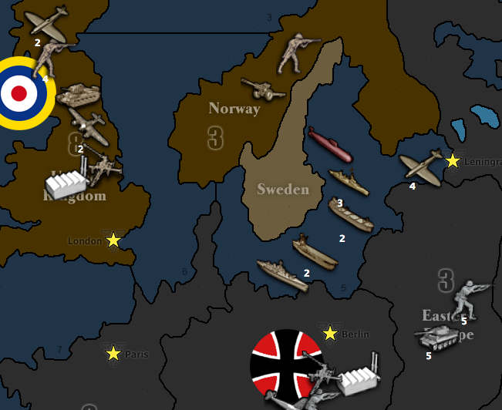

*Fig. 14.* The German player did not pay attention to British airpower and is about to suffer heavily for it. Britain sends all 6 fighters and 2 bombers he has into Eastern Europe, and has his transports pick up 4 infantry from the UK to drop off into Eastern Europe as well, to serve as fodder. In battle, the British battleship in the Baltic misses the naval bombardment hit, but the combined infantry-aerial force inflicts 6 casualties on the Germans—5 infantry and a tank. The Germans strike back and roll 3 hits against the British infantry. At this point, the British player has only 1 infantry fodder left and does not want to risk losing any of his fighters in a second round of combat, so he withdraws all his planes and leaves his remaining infantry to die. The luckless infantry misses his shot and gets killed by a German tank. However, Britain has reason to be content—he had just killed 5 German infantry and 1 German tank at the cost of 4 British infantry. While this may not be an impressively large kill ratio, keep in mind that Germany was probably depending on his Eastern Europe army to serve on the front lines against Russia and has just been placed in a position of considerable disadvantage—Britain’s losses were replaceable, Germany’s was not. The continual bleeding of German forces will eventually lead to collapse.

**Tactical Reserves.** Players can take advantage of the mobility of tanks and planes by holding them in reserve as an attacking or counterattacking strike force that can be committed to one of several places instead of putting them on the front lines. The presence of reserve forces is also a psychological tool to make your opponent act with caution.

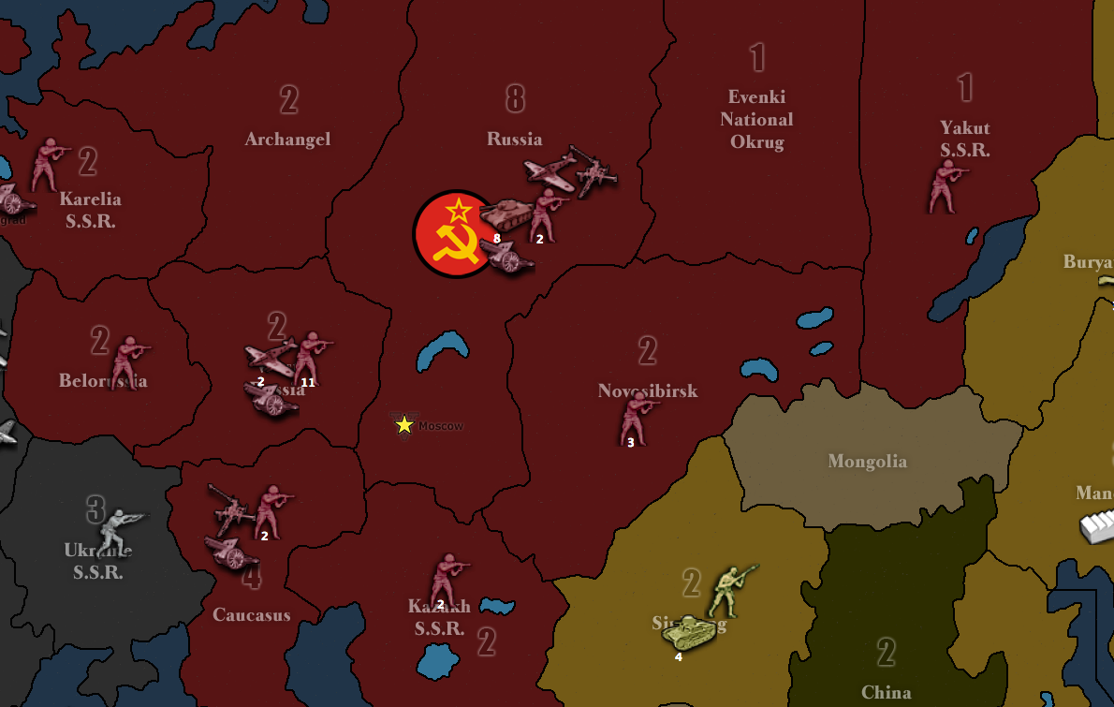

*Fig. 15.* Russia is holding 8 tanks in reserve in Moscow instead of putting them on the front lines. This gives him lots of flexibility and the ability to respond to a wide range of threats. These tanks can serve to counterattack any Japanese incursions in Yakut, Novosibirsk or Kazakh, any German incursions in Karelia or Caucasus, or to make a move into Ukraine. Using tank reserves that can be committed to multiple places depending on enemy moves enhances Russia’s ability to fight and respond to a two-front war.

**Lines of communication.** Analogous to real-life warfare, lines of communication in TripleA refers to the path between your industrial centers (factories) and the front lines. The further you push into enemy territory, the longer your lines of communication will be and the more strained your logistics. A longer line of communication means a longer delay in being able to respond to changing front-line conditions. In other words, the longer the distance between your factories and the front lines, the longer the time it takes for your builds to take effect on the battlefield. For example, if you suddenly realize you are running out of infantry cover on the front, it will take a while for your newly-built infantry to arrive and correct the situation.

**Defense in Depth.** Also analogous to real-life warfare, defense in depth refers to the trading of space for time, retreating to husband your resources while sapping the momentum of your opponent, in order to shorten your line of communications while straining those of the enemy. The goal of defense in depth is to allow the enemy to penetrate deeply into your territory and then hopefully annihilate the invading army with a strong counterattack. Having tank and plane reserves are often essential components of this tactic.

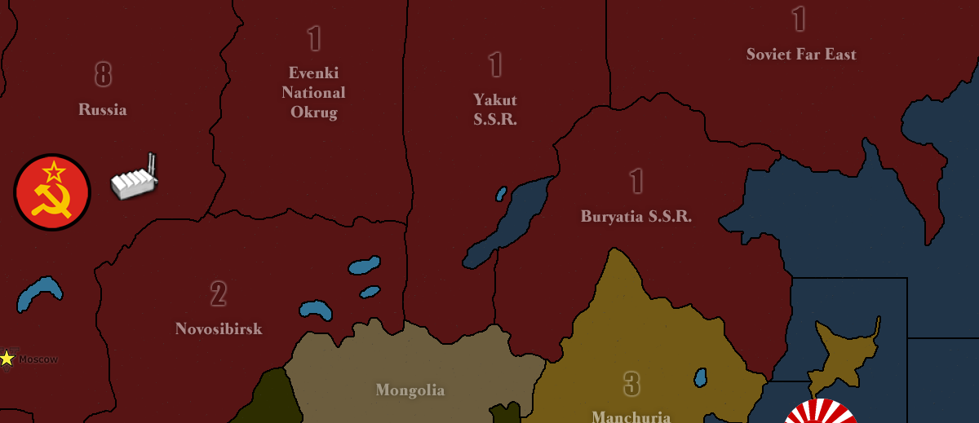

**Russian counterattack**

**Russian retreat**

**Japanese Invasion**

*Fig. 16.* Russians conduct defense in depth.

A country like Russia has plenty of space to trade and sometimes finds it effective to retreat its main forces to the factories, where they can be reinforced with builds and carry out counterattacks.

**Forward retreat.** This is a neat trick takes advantage of the combat retreating rules in order to make units go where they normally will not be able to reach.

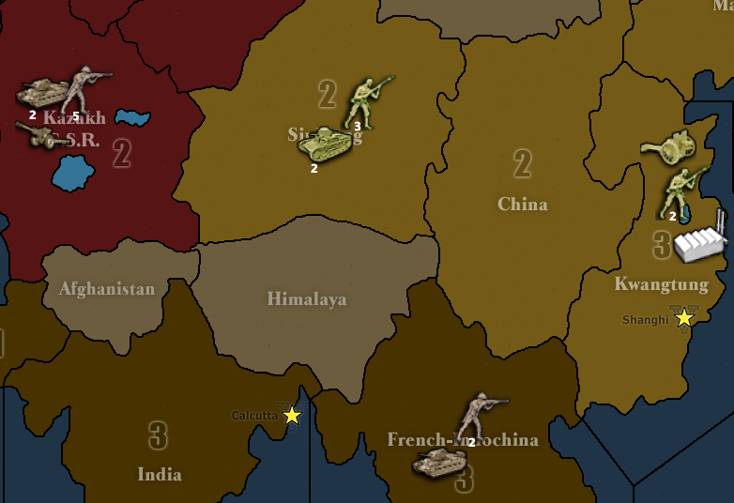

*Fig. 17.* The British attack Sinkiang with their army in Kazakh, and their tank in French Indo-China joins the battle as well. After 1 round of battle, the British kill 3 Japanese infantry and takes 2 infantry casualties and retreats all units to China. He is able to do this because one tank attacked from the direction of China and combat retreats can occur to wherever any attacking units come from.

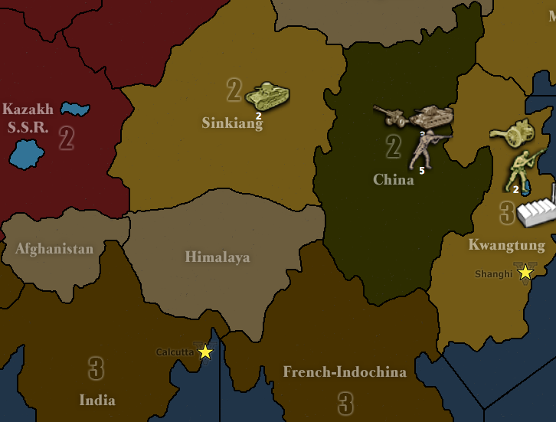

*Fig. 18.* The result of the forward retreat.

**Submarine warfare.** Subs are tricky units because they can slip though hostile seas, but enemy ships (except other subs) can’t slip though a sea blocked by a sub (in some newer maps, subs do not block other sea units). This makes subs very effective blocking units, and combined with their ability to submerge, means that they don’t have to be sacrificed if they get lucky rolls. Subs also make great cheap defense against an enemy carrier-centered fleet, because the subs’ sneak-attack targets exclusively ships and can sink the carriers upon which enemy planes depend for landing.

**Anti-submarine warfare.** Air units can hit submarines, but submarines cannot fire at planes, making air units the ideal risk-free anti-submarine weapon. If the aerial sub-hunters miss their shots, however, the submarines can get away by submerging, so sometimes players like to bring a destroyer along as well, to prevent subs from diving. (in some newer maps, a destroyer-type unit is required to join the battle in order for your air units to hit submarine units)

**Escorting.** Transport ships have nearly no defenses against being attacked at sea or from the air, and it is essential to protect them with ship escorts that can deter air or submarine raids. Nobody wants to turn a ferry service into a turkey shoot.

**Fleet-in-being.** A fleet-in-being is a fleet that stays in port, preserving its strength and integrity by avoiding direct battle, instead relying on its very existence to project influence over the seas. A fleet that engages in a large battle runs the risk of suffering crushing defeat which will permanently grant the opponent the upper hand. A fleet-in-being, on the other hand, by preserving its existence, can serve as a form of deterrent to influence enemy actions and forces the opponent to act with caution. Fleets-in-being are usually used by the weaker side who cannot afford to replace their expensive naval losses should they risk battle. The German Kaiserliche Marine during WWI was a historical example of a fleet-in-being in practice, since the German naval command was unwilling to risk their fleet in major battle and thus avoided defeat by the British Royal Navy. In TripleA, a fleet-in-being is a useful tool of deterrence for denying the enemy the ability to scatter its forces, limiting their ability to maneuver.

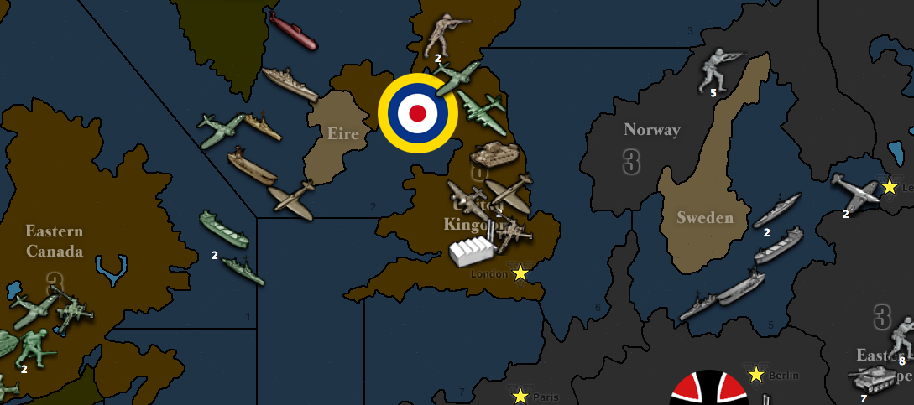

*Fig. 19.* The German Baltic fleet, by avoiding being destroyed in battle, can deter the Allies away from Sea Zones 3, 6, and 7 for at least a few rounds. However, the German fleet-in-being can only last for so long before the Allies build up an overwhelming superiority and decide to destroy it once and for all.

Alternatively, the fleet-in-being concept can also be applied on land as armies-in-being by weaker powers who wish to preserve their threat-posing capability in order to maneuver the enemy.

Thank you for Reading, and for playing TripleA